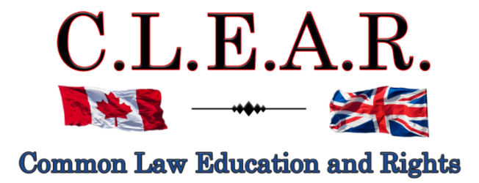

“Promoting Freedom in B.C.”
Freedom activists are critical thinkers!
Our society is so dumbed down and indoctrinated that anyone who is a critical thinker is labeled as a Conspiracy Theorist to avoid critical debates

Did you know: The term ‘conspiracy theorist’ was first coined and used by the CIA to ridicule anyone who opposed the gov’t narrative?
--------------------------------------
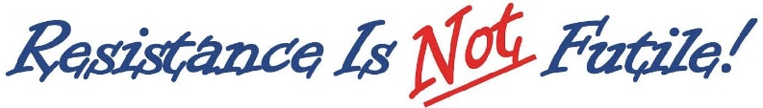
--------------------------------------
It is important to come out on Saturdays to oppose all Gov’t corruption and support others. Visibility = Credibility.

Next rally is:
Saturday

August 30, 2025
Hwy 97 & Cooper

September 6, 2025 -- Stuart Park!!

Help us give away hundreds of Druthers every week to supporting drivers and public!
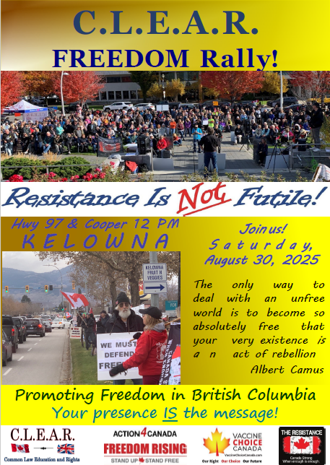

City of Kelowna v David Lindsay et al
Petition to Stop Rallies at Stuart Park
August 26, 27, 2025

IMPORTANT LEGAL UPDATE – FREEDOM OF EXPRESSION CASE

Dear Supporters,

We want to provide you with a critical update regarding our legal battle for freedom of expression.
Our three-day hearing, originally scheduled for the week of March 10, 2025, had been adjourned once again. We are now set for two days this week. Originally set for three days, and on agreement with the City for four days, further scheduling issues has limited us to two days this week, and there will be a further adjournment to an unspecified date.
Please support us at court tomorrow. Unfortunately, due to late notice from the Court, it was difficult to get more advance notice of this hearing date.
A brief description of this case is set out below.
Further details on the falsified assault conviction will be sent out later this week as well.
The continuation of this hearing is now set for two days this week of August 26, 27:

10:00 a.m.
Courthouse
1355 Water St.
Kelowna, BC

The City’s Legal Attack on Freedom of Expression
This case began when the City of Kelowna filed a Petition seeking an injunction to shut down our rallies and ban us from key downtown areas—the most effective locations for public demonstrations.
In response, we filed a comprehensive legal defense, including our Response, supporting affidavits, and a SLAPP Application to strike down the City's injunction. This move completely blindsided the City, which had not anticipated such a strong legal counteraction
Our documents in this case are located on our website at:

https://clearbc.org/david/
City of Kelowna documents and pleadings are now placed on our website for public viewing:

https://clearbc.org/city-of-kelowna/

What Is a SLAPP Application?

https://www.bclaws.gov.bc.ca/civix/document/id/complete/statreg/19003

A SLAPP (Strategic Lawsuit Against Public Participation) Application is a legal mechanism designed to prevent powerful entities from silencing public expression through litigation. In this case, the City—armed with virtually unlimited taxpayer-funded resources—is attempting to suppress our fundamental right to peaceful, public protest.
This is precisely the type of government overreach that SLAPP legislation was enacted to prevent.
The City’s Dangerous Argument
The City of Kelowna’s position represents one of the most dangerous attacks on free expression in Canada. Their argument is that without a permit to use sound equipment, our protest is not truly a protest—it is merely a silent gathering, or event as they falsely term it.
This logic undermines the very foundation of free expression. Requiring a permit for protest implies that protesting is banned by default, unless
explicitly approved by the government.
However, the Supreme Court of Canada (SCC) has repeatedly ruled that freedom of expression includes not just the right to speak—but the right to be heard.
To illustrate this, we played a video of David speaking at our Freedom Rally when our generator went out—immediately, people could no longer hear his words. This proves what we all know: effective public expression requires the ability to communicate clearly, which includes, indeed, requires the use of sound equipment.
Furthermore, both the SCC and lower courts have consistently upheld that public parks, streets, and sidewalks are Constitutionally protected places for peaceful protest. Even the RCMP has acknowledged that our demonstrations have been entirely peaceful.

City's Flawed & Misleading Claims
The City argues that our demonstrations qualify as an "event," which under their bylaws requires a permit. However, the term “event” is not even defined in their bylaws.
Their position is based solely on:
- Our use of sound equipment
- The presence of our CLEAR canopy, which they have falsely labeled as a tent
- Allegations that CLEAR and David were selling merchandise
These weak and arbitrary claims do not—and cannot—turn a lawful protest into a licenced "event." Even if certain bylaw infractions were alleged, that does not justify stripping us of our Constitutional rights.
Additionally, the City has provided no evidence that David or CLEAR were selling anything. Only that other people were. And I have not been deputized by the City to enforce their bylaws, as former Bylaw Manager Kevin Mead admitted.
Not to prejudge, but the Justice in this case, I believe has already recognized that the City is going nowhere with their claim that our CLEAR Canopy is an alleged, “tent”.
In effect, the only thing the City really has in evidence that we were allegedly holding an undefined “event”, is that we used sound equipment and advertised our Freedom Rallies.
All protests involve advertising or they would never take place. This is an absurd, and indeed, stupid argument.
The use of sound equipment is what is legally known as “necessarily incidental” to our freedom of expression. Without the sound equipment, we could not effectively communicate, and at times with many people, not at all.
By doing this, the rallies become more of a social function, than a protest, because no one can effectively communicate to everyone else.

Our SLAPP Application: A Strong Legal Defense
Our SLAPP Application is incredibly detailed and well-prepared. As the legal maxims state: “Fraud lurks in generalities”, and, “the details make all the difference.”
The City’s strategy is clear:
- Ignore Constitutional law and attempt to redefine protesting as a regulated activity.
- Gloss over key legal principles and hope the courts accept their broad, unfounded claims.
- Bylaw us out of existence—forcing us away from public spaces and out of the public eye.
But we refuse to be silenced.
We knew we had to be meticulously prepared, with extensive evidence and legal arguments to counter every false claim. And we are prepared.
The Broader War on Free Speech
This case is not an isolated attack—it is part of a coordinated effort to suppress free expression across Canada, particularly in British Columbia and Alberta.
- Online censorship is expanding.
- Private interest groups, funded by the government, are targeting businesses that support free speech, threatening them with boycotts and false accusations. Many businesses break contracts with us at the last minute out of fear.
- Municipal governments are being weaponized to push freedom advocates out of public spaces.
- And most recently under the Communist Liberal Government, ongoing refusals to permit certain media outlets into their press releases and government functions, to ensure only Liberal Government supported media is allowed in.
Their tactic is simple: Out of sight, out of mind. If they can erase us and our messages from public view, they believe they can stifle dissent.

Why This Fight Matters
Our Kelowna public rallies have empowered thousands to get involved in defending freedom. The truth we have exposed has reached all corners of British Columbia, shedding light on the deceptions of government officials.
Just in the past six weeks:
- Three complete strangers have approached me, expressing their gratitude for what we have done.
- One person emphatically stated, “There are thousands of people supporting you.”
- A public health employee confided that many of their colleagues supported us but were too afraid to speak out.
These silent supporters will only be able to stand with us if we remain in the public eye.
Requiring a government license to protest is unacceptable. If we comply, we further surrender our right to spontaneous demonstrations, which are at the heart of effective activism.

How You Can Help
This is one of the most important free expression cases in Canada. Only three provinces have SLAPP legislation similar to what we have in British Columbia.
We need your continued support—legal battles like this require time, effort, and resources.
If you believe in freedom of expression, there are three ways you can help: time, energy or financial. Please choose at least one to contribute to our case and our Freedom Rallies.
Next Steps: Stay Engaged
As soon as the courts provide us with new hearing dates, we will notify you immediately. Please show up at court and voice your support of our position
In the meantime, spread the word, stay informed, and stand with us. The fight for freedom of expression is far from over—but together, we will prevail.
The BC Government will use this case, via its municipalities, to eventually shut down all public protests, if we lose. Make no mistake, despite the City’s colourable guise of claiming it is only bylaw enforcement and they don’t care what we talk about, this is an outright lie. The only person charged with having public rallies is David – despite dozens of other protests using sound equipment over the years on other topics that either supported the governments or were non-threatening to them.
CLEARLY, our rallies have had far more success behind the scenes, than we can see. Our signs, some of the best, including LOCK HER UP – Bonnie Henry, remain some of the strongest signs voicing not only our opposition to what these Government people have done, but demanding accountability.

Thank you for your unwavering support.
--------------------------------------

Dr. Trozzi and Ted Kuntz
Wins of the Week - #87 – August 24, 2025

https://www.drtrozzi.news/p/wins-of-the-week-ep87-with-ted-kuntz?utm_campaign=email-half-post&r=1ri3is&utm_source=substack&utm_medium=email
--------------------------------------
Remember the Freedom Principle:

An attack against one is an attack against all.
An attack against all, is an attack against one.

