

“Promoting Freedom in B.C.”
Freedom activists are critical thinkers!
Our society is so dumbed down and indoctrinated that anyone who is a critical thinker is labeled as a Conspiracy Theorist to avoid critical debates

Did you know: The term ‘conspiracy theorist’ was first coined and used by the CIA to ridicule anyone who opposed the gov’t narrative?
--------------------------------------

--------------------------------------
It is important to come out on Saturdays to oppose all Gov’t corruption and support others. Visibility = Credibility.

Next rally is:
Saturday

September 6, 2025 -- Stuart Park!!

September 13, 2025

Hwy 97 & Cooper

Help us give away hundreds of Druthers every week to supporting drivers and public!
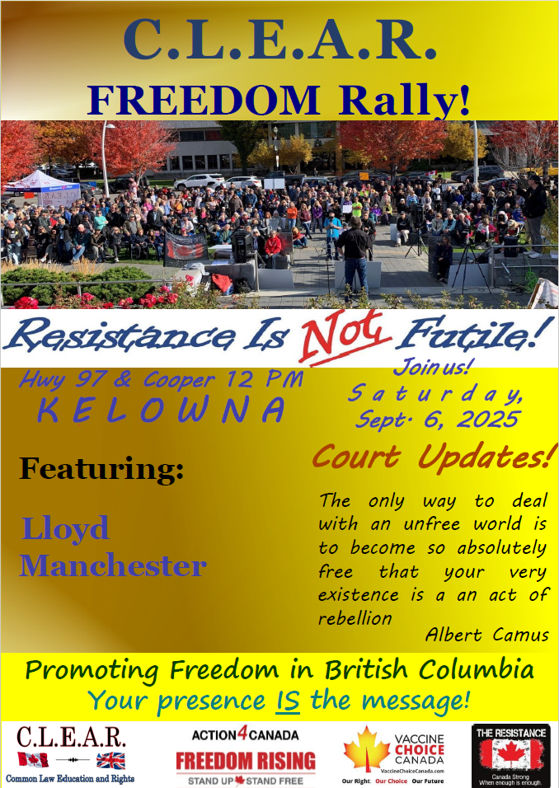
--------------------------------------
Thank you to Druthers for printing my article in their August edition. You can see my entire, unedited 4-part article, which I have re-titled:

Criminalizing Dissent: Suppressing Freedom of Expression in Canada here:
https://clearbc.org/clear-blog/
--------------------------------------
City of Kelowna v David Lindsay et al
Petition to Stop Rallies at Stuart Park

IMPORTANT LEGAL UPDATE
FREEDOM OF EXPRESSION CASE
FALSIFIED ASSAULT CONVICTION APPEAL

Dear Freedom Supporters:

We want to provide you with a critical update regarding our legal battle for freedom of expression.
Continuation of the hearing for our SLAPP application finished this past Friday, after four days of hearing before Justice Hardwick all week.
Kelowna filed a Petition to obtain an injunction to ban our rallies throughout the entire downtown Kelowna area, the most effective areas in the City.
In turn, we filed what is known as a SLAPP application (Strategic Lawsuit against Public Participation), pursuant to the Protection of Public Participation Act. The acronym says it all – the Petition is an action designed to prohibit our public participation at Stuart Park exposing gov’t corruption and lies.
https://www.bclaws.gov.bc.ca/civix/document/id/complete/statreg/19003
Below are my brief notes from each day of last weeks’ hearing. Justice Hardwick has reserved judgment in this case. There is no set date for the release of her judgment.
We urge everyone to pray for success in this case. This type of case has never been heard in Canada and we need God on our side to ensure a precedent in our favour. Please pray that J. Hardwick will come down on the side of freedom.
Our Court documents in this case are located on our website at:

https://clearbc.org/david/
City of Kelowna documents and pleadings are now placed on our website for public viewing:

https://clearbc.org/city-of-kelowna/

Our SLAPP Application: A Strong Legal Defense
Our SLAPP Application is incredibly detailed and well-prepared. As the legal maxims state: “Fraud lurks in generalities”, and, “the details make all the difference.”
The City’s strategy is clear:
- Ignore Constitutional law and attempt to redefine protesting as a regulated activity.
- Gloss over key legal principles and hope the courts accept their broad, unfounded claims.
- Bylaw us out of existence—forcing us away from public spaces and out of the public eye.
But we refuse to be silenced.
We knew we had to be meticulously prepared, with extensive evidence and legal arguments to counter every false claim. And we are prepared.

The Broader War on Free Speech
This case is not an isolated attack—it is part of a coordinated effort to suppress free expression across Canada, particularly in British Columbia and Alberta.
- Online censorship is expanding.
- Private interest groups, funded by the government, are targeting businesses that support free speech, threatening them with boycotts and false accusations. Many businesses break contracts with us at the last minute out of fear.
- Municipal governments are being weaponized to push freedom advocates out of public spaces.
- And most recently under the Communist Liberal Government, ongoing refusals to permit certain media outlets into their press releases and government functions, to ensure only Liberal Government supported media is allowed in.
Their tactic is simple: Out of sight, out of mind. If they can erase us and our messages from public view, they believe they can stifle dissent.
Thank you for your unwavering support.
--------------------------------------
Tuesday, August 26, 2025
Court hearing
Kelowna v Lindsay, Manchester et al

Thank you to everyone who showed up to support us today!!! The courtroom was full!
We arrived at court approximately 9:30. All was well until a female Sheriff decided to abuse her powers, by demanding to search everyone. I have gone through this process with this same abusive Sheriff in the past, who seems to think that because she has powers, she can abuse them, at our expense.
Others started objecting as well. A male Sheriff arrived from the next courtroom and began to demand we be searched. His position was that we had a choice, we could refuse and would be forced out of the courthouse.
Again, I reminded him we have a Constitutional right to be there, and I have a legal duty to be in court. He didn’t care and his position was that safety outweighs out Constitutional rights and freedoms. Another heated argument broke out on this issue.
Lloyd, though initially opposing, reluctantly allowed the male Sheriff to search his legal bag.
The female Sherriff wanted to search my shopping bag which contained my computer and cords. I left my computer knapsack at home specifically to avoid this. Previous court appearances have not resulted in any search of my shopping bag and computer.
I threw the shopping bags into the garbage and left my computer in the bankers box of documents.
Meanwhile, counsel for the City readily agreed to give up their Constitutional freedoms and have their bags searched. The Sheriffs were not going to search them until they offered.
Finally, finally we were able to enter the court, albeit late.
After setting up, we began with hearing our application for new evidence from Lloyd and myself in relation to the actions of the City over the past year. Lloyd was evidencing that the City had not charged him at all for conducting these rallies. I evidenced how the recent protests by the atheists at City Hall, with sound equipment, resulted in no charges to them, and they did not have a permit.
The City’s counsel objected claiming that we were too far along in the proceeding, and that with cross examinations, it would unduly prolong this case even further.
The City filed and affidavit from City official Laura Bentley, claiming, to our surprise, that the City was in fact charging Lloyd with offences for conducting the rallies. She attached a copy of a Statement of Account claiming about $9 500.00 in fines for Lloyd now!
However, the address listed on the Statement, was an address Lloyd had not lived in for over three years!! This should have been on the City’s tax records with a new owner and the City must have been aware of this. So, the City was serving Lloyd with tickets to an address he does not live in.
I pointed out that the City at no time said they would want to cross examine to invoke this right, and thus was a red herring of an argument.
This was all new evidence that occurred after the Sept. 2024 hearing and was relevant to show improper actions by the City.
Unfortunately, this afternoon, Justice Hardwick ruled that my evidence was merely in support of our existing application and existing evidence, so though somewhat relevant, was not something that the case would turn on.
J. Hardwick did however, state that she would have accepted Lloyd’s affidavit if not for the existence of Ms. Bentley’s affidavit. Because there was conflicting evidence, this would have required cross examinations which would unduly delay this case further. So, our application for new evidence was declined.
I continued in the morning to present the remaining part of our case to the Judge. I then provided a cursory overview of our Constitutional Challenge to the bylaws and why the City was not going to win against our Challenge. This continued into the afternoon.
After this, I proceeded to address the City’s Written Response to our SLAPP application.
The City’s primary position is that the Bylaws must be given a broad interpretation, and that an ‘event’ includes protests or any other similar activity in a park. Also, that the street marches we did, and standing on Water St., constituting loitering, if you can believe that.
I took great pains to accurately legally define this and how it simply didn’t apply. The City’s interpretation of its own Bylaws is so stupid and absurd as to defy logic. How the City thinks it can licence a Constitutional freedom of protest, including fees, insurance, and other commercial requirements, is beyond my understanding. Just corrupt City officials following orders from a corrupt Provincial Gov’t in Victoria. (as Mayor Dyas admitted to me that is who is pressuring them to take this legal action against us – which started when Mayor Basran was in power.)
(SLAPP – Strategic Lawsuit Against Public Participation) pursuant to the Protection of Public Participation Act, B.C. This is where someone files a court proceeding with the intention or effect of shutting down freedom of expression, exactly as the City is doing.
A few minutes later I was made aware that the City had not served their Written Submissions on the Court. I was completely unaware and did not feel comfortable making submissions to the Judge on a document she did not have before her.
Apparently, the City files this when they make their oral submissions to the Judge. As a result, I then provided the Judge with an overview of my entire position, and Lloyd came up to speak around 3:25 p.m.
We ended at 4:00 p.m.
Though Court was originally set for three days in the spring, which I did not feel comfortable with, two months ago I sought a fourth day, knowing this was going to take longer.
We learned on Friday, that we had two days this week, as J. Hardwick was committed on a criminal hearing on Thursday and Friday. We learned today, however, that this might be shortened to one day, and we may get a third day in this week on Thursday. We won’t know until tomorrow (Wednesday.)
One of the drawbacks about being in the Supreme Court is that the hours available in a day to make representations is shorter by an hour each day, from Provincial Court.
And the Assize System of setting dates is so prejudicial for everyone, litigants and the public who want to watch but need advance knowledge to plan accordingly.

In freedom
David

----------------
Wednesday August 27, 2025
Court hearing
Kelowna v Lindsay, Manchester et al

Thank you to everyone who showed up to support us today!!!
As with yesterday, Aug. 26, the blonde female Sheriff was present again. With nine (9) courtrooms, we were the only courtroom that was once again targeted for being searched, despite this being only a civil case.
The Sheriff began telling everyone that they had to be searched again to enter the courtroom. and it was voluntary but if you didn’t voluntarily agree, that she would evict you from the courthouse. She wanted to check my open bankers box that was only ½ full of documents, despite not checking yesterday.
I repeatedly inquired as to why and she refused to answer me. She continually demanded to search it or she was going to evict me. Upon further inquiries by me, she claimed she was a peace officer and threatened to charge me with obstructing a peace officer – for simply refusing to be searched without reasonable grounds to so do.
This Sheriff was rude and obnoxious to everyone in attendance, harassing everyone throughout the day. She asked John, who was sitting in the hallway in the morning before Court started, if he was video recording. He replied no he was looking on the net for something.
The female Sheriff, threatened him that their cameras could see what was on his screen. She then called backup on her microphone and told them to use the cameras to look on his phone! If so, this is a massive privacy violation, in addition to unconstitutional searches.
Finally, court began.
To refresh your memory. The City filed its Petition seeking an injunction against us from protesting, not just at Stuart Park, but everywhere in downtown Kelowna. In response, we filed our SLAPP (Strategic Lawsuit Against Public Participation) Application, to strike the City’s claim. This was originally heard last Sept. and due to scheduling problems with the Court, was adjourned to this week.
Here is the applicable SLAPP legislation we are relying upon:

Application to court
4(1) In a proceeding, a person against whom the proceeding has been brought may apply for a dismissal order under subsection (2) on the basis that
(a) the proceeding arises from an expression made by the applicant, and
(b) the expression relates to a matter of public interest.

(2) If the applicant satisfies the court that the proceeding arises from an expression referred to in subsection (1), the court must make a dismissal order unless the respondent satisfies the court that
(a) there are grounds to believe that
(i) the proceeding has substantial merit, and
(ii) the applicant has no valid defence in the proceeding, and
(b) the harm likely to have been or to be suffered by the respondent as a result of the applicant's expression is serious enough that the public interest in continuing the proceeding outweighs the public interest in protecting that expression.

Lloyd continued with a masterful presentation today and into the early afternoon. His evidence was awesome, as was his analysis of Ted’s affidavit, filed in this case. He took the judge through all of our speakers at these rallies, demonstrating the massive public interest in the importance of the COVID-Con issues.
Lloyd is also supporting our Constitutional Challenge to these Kelowna Bylaws that the City is relying upon: Parks Bylaw, Good Neighbour Bylaw, Traffic Bylaw (street marches), and Outdoor Events Bylaw, that they claim we need to get a permit under, to protest in Stuart Park.
Around 2:20 p.m., Nick Falzon, counsel for the City addressed Judge Hardwick. His opening presentation centered around the City’s claim that under the Protection of Public Participation Act (PPPA), the City’s Petition did not “arise from” the content of our expressions at the Freedom Rallies. Falzon argued that s. 4(1)(a) of the PPPA only relates to content of speech, that the City was not attacking our content, and the bylaws are content-neutral in that they apply to everyone.
Really – then why after 20 years at Stuart Park, am I the only person who has been charged with holding protests using sound equipment? To the amount of over $60 000.00 in fines!
The City spent almost 20 pages out of a 40-page Response, just on this one issue. The objective is to try and make sure our Application does not get heard on the merits, of whether they have substantial merit to their case, whether we have any valid defences, or the weighing exercise at s. 4(2(b), to determine who will suffer the greatest harm.
Falzon is back in court tomorrow for the City as is his obnoxious, arrogant partner lawyer Barry Williamson. If an attitude problem were an indicator of success, Williamson would win every case.
After court, I stopped by the Sheriff’s office and complained to the Chief Sheriff, who is usually pretty reasonable. I advised him of this female Sheriff’s comments, demeanour, attitude and actions toward everyone. Lloyd was clear, we were the only people in the courthouse being searched and this was wrong.
I respectfully told the Sheriff to not have her back in our courtroom tomorrow and to confirm if these hallway ceiling cameras can actually see people’s phone screens. We will find out tomorrow if this female sheriff is returning.

----------------
Thursday August 28, 2025
Court hearing
Kelowna v Lindsay, Manchester et al

Thank you to everyone who showed up to support us today!!!

This was the third day in court, with one more to follow.
After court yesterday, I stopped by the Sheriff’s office and complained to the Chief Sheriff, who is usually pretty reasonable about the actions, demeanour and comments of the female Sheriff in our courtroom the past two days. I advised him of this female Sheriff’s comments, demeanour, attitude and actions toward everyone. Lloyd was clear, we were the only people in the courthouse being searched and this was wrong.
I respectfully told the Chief Sheriff to not have her back in our courtroom today and to confirm if these hallway ceiling cameras can actually see people’s phone screens.
Upon our arrival to the courthouse, two Sheriffs were searching everyone coming in the building. They searched Lloyd’s bag with his legal materials. My ½ empty open box was not searched. Nonetheless, we made sure the Sheriffs knew that we were not happy with the unconstitutional searches without reasonable and probable grounds.
We proceeded up to courtroom #5 to be greeted by a wonderfully nice and respectful Sheriff. His presence made the day go by so much better and relaxing.
Court began with City counsel Nick Falzon continuing his presentation to Justice Hardwick.
He began by representing that the issue is about responsible management of public space and that our protests were “highly disruptive” of others to use the Park.
I emphasize, there is no evidence presented from anyone to this effect.
No affidavit from anyone saying they wanted to use the park and could not because of our presence.
Counsel continued to claim that the City’s Petition was not to harass us but only to enforce City bylaws against sound equipment, despite the fact that all enforcement action has been against us only.
He claimed that case law has insisted that municipal bylaws be given this wide and broad interpretation pursuant to the scheme of the bylaws and what they were designed to do. Ordinary principles of statutory interpretation did not apply, only the fact that municipalities can pass bylaws into a wide variety of examples, because they cannot foresee every situation that may come up. Courts give deference to the municipalities in so doing.
Falzon argued that the objectives of the bylaws override any errors or deficiencies in the bylaws, such as lack of definitions. He argued the Court can fill in the gaps by reading into the bylaws that which is not stated.
He further argued that the definition of “expression” in the Protection of Public Participation Act, was narrower then in the Charter, but again, nothing turns on this as all our expressions are subsumed in the PPPA definition anyway.
He claimed that the Parks Bylaw, having no definition of an event, should include protests, be licenced with fees and insured. The City is benevolently passing bylaws for the public, and they should be given precedence over our protests, which the City claims, without evidence, that we were causing a nuisance and public disturbances with our rallies.
He opposed our argument that because the City has a trust agreement, that the City does not own or lease Stuart Park. This is important because the Parks Bylaw and Outdoor Events Bylaw both stipulate that the City must own or lease the land.
Also, that the City’s contractual promises with the Province for a $500 000 grant to build Stuart Park as a “public or town square” specifically for the purpose of public speaking, still allowed them to licence Constitutionally protected rights of protests and assembly.
The City is arguing our defences that the City’s interpretation of its bylaws is incorrect, and should not be accepted.
Finally, he argued that if there was a 50-50 chance we might win our Constitutional challenge or other defences, a case law ruled that the judge must rule in the City’s favour. This is amazing.
After the lunch break, the City began with presentations by the ever arrogant and smug, Barry Williamson, who argued that our Constitutional challenge cannot be successful. The City is arguing that other cases have allowed blanket bans using sound equipment, even though their use is Constitutionally protected. The City is arguing that s. 1 of the Charter applies to override our freedom of protest, even though parks are Constitutionally protected venues for expression, because bylaws passed by municipalities deemed to be for the public interest and thus deserving of higher protection.
These other cases however, are factually and legally different than our case and they bylaws here in Kelowna.

----------------
Friday, August 29, 2025
Court hearing
Kelowna v Lindsay, Manchester et al

Thank you to everyone who showed up to support us today!!!

Court started on a good footing. We were able to get into the courtroom without being searched or even asked. The female Sheriff that harassed us the first two days, was again, nowhere to be found, gratefully. Thursday and Friday was so much more relaxed as a result.
Court began on time, with myself speaking in response to the City’s arguments for the morning. Counsel for the City had a couple of objections but nothing major. I am pretty sure I managed to address all their legal issues. One issue stood to be addressed, however, that I was unsure about. J. Hardwick was going to ask some questions but did not.
After lunch, Lloyd completed his presentation in response to the City’s submissions and I then inquired of the Justice what questions she had. She mentioned that my presentation in the morning had pretty much answered all her questions except one. This was in relation to para. 10 of the Reynolds case, on the City’s submissions as to the appropriate test to be applied to a SLAPP application, either the causality/historical test, or the analytical test, and the Justice wanted to know which one I thought should be applied.
I really did not understand this point, and so asked for an explanation, which the Justice provided. I was not overly excited about having to address this relatively new issue on the fly – but my response I think satisfied her. Why do I need to choose? Either one could apply depending on the facts of the case and our legislation. That kind of surprised her as the City counsel kept arguing it could only be one or the other.
I further pointed out if there had to be one or the other, it would be the causality/historical test, as this best complies with the wording and scheme of the statute (s. 4(1)(a) of the Protection of Public Participation Act). The statute looked to past tense events of expression, so why should any other test but a historical test apply?
I think she was satisfied with this answer, though I really did not have time to fully study this case and its implications. Had I been able to do so, I likely could have elaborated in much more detail upon this point.
I then passed along a new case to the Justice, advising her that if she was to come across any new issues/case law/principles in her deliberations that were either not discussed in Court or not before the Court, under the Constitutional principles of natural justice and procedural fairness, she would be required to contact both parties and obtain our position on the matter. Despite not being aware of this case, she agreed it was correct and if she came across anything new, she would contact us for either submissions in writing or another ½ day in Court for oral submissions.
I have noticed in past judgments, in relation to comments that are made in the decisions and I think to myself, “We never discussed that in Court.” I wanted to avoid this at all costs here to ensure we responded to everything.
J. Hardwick, as expected, reserved judgment. She has also ordered transcripts for herself for all hearing dates so far.
Both the Justice and even City counsel concede that this is a precedent setting case. No one has sought application of the SLAPP legislation to municipal bylaws anywhere in Canada in the past, though counsel has conceded that there is nothing in the B.C. legislation that prohibits it from applying to municipal bylaws.
This is a complicated case, with a lot of moving parts. The City raised five bylaws that we are attacking in our SLAPP application, based on a factual and legal interpretation of each of them being incorrect, as well as our Constitutional Challenge to these bylaws, plus showing how our position meets the SLAPP test in law. We also had the City’s submissions on the broad application to be given to City bylaws to contend with. My question is obvious: what do you do when you get a requirement to give bylaws a broad interpretation, and our Constitution a broad interpretation? Which governs? Clearly it must be the latter.
Both myself and Lloyd share concerns about the “David v Goliath” situation here, with the City hiring one of the top municipal law firms in the province against us. We hope that there is no inherent bias or prejudice against us in that regard, because the Court generally does not like to see unrepresented litigants win against major experienced, counsel, even if they are wrong, as is the case herein.
No lawyer wants to go to work and have unrepresented litigants beat them on precedent setting issues. Colleagues and the City then ask, why are they paying them all this money if we can beat them? “You had those unrepresented freedom guys beat YOU?” Ha ha ha ha ha!
Make no mistake, Justice Hardwick has not shown any bias toward the City counsel in this case in the Courtroom to date, and has been entirely professional and respectful to everyone, including us. She did however, have a lot of questions for me last hearing in Sept. 2024, and had only one question for City counsel. This has me worried a bit. Frequently, this is because the judge is already predisposed to the other party.
Having been in court hundreds of times, and talked to lawyers around the country, I know that there are serious politics going on behind the scenes in this case, and I made sure to tell the Justice that this is nothing but a political case being played out in the Court. The City will stop at nothing to have public protests be converted from a Constitutional freedom, into a licenced privilege. I know City counsel has been in contact with the Crown behind the scenes as well. The Crown, despite any claims of judicial independence, has connections into the judiciary. To what extent, remains unknown.
Though I am 100% certain our position in law is correct, nothing in a Court is guaranteed. We need your ongoing prayers to God that His will is for us to be successful, with the Justice upholding our Constitutional freedoms and not allowing the City further deprivations of same.
I finished my presentation by simply telling the Justice: “Do the Honourable thing!” Clearly in reference to ruling in our favour, as we believe that the law requires.
We will keep you posted when judgment is ready to be delivered. No date has been set, but this case has gone on for some time. I hope the Justice does not use this as a reason to rush her decision, even though the City keeps complaining that they can’t enforce the bylaws until this case is heard. They shouldn’t be able to after judgment either! There are hundreds of authorities before her, huge affidavit evidence, transcripts of cross-examination of City Bylaw Manager Kevin Mead, oral submissions, statutes, bylaws, statutory interpretation and Constitutional issues. This decision should not be rushed.
As I wrote in my article on the attacks on freedom of expression in Canada in the August edition of Druthers, the attacks are getting worse. The Federal Gov’t is now trying to criminalize protesting in various bubble zones that they will create, coming this fall session of Parliament.
Destructive incrementalism of our rights and freedoms has got to stop – and this is the perfect case for this to happen.
Thank you to Lloyd for joining this case and his incredible work, insights, and presentation to the Court. This would not have been the same without him!
And thank you to all who braved the unconstitutional searches to watch these proceedings in court all week as well!

In freedom
David
--------------------------------------
Courts

Falsified assault charge
Kelowna Courthouse
R v David Lindsay s. 266 Criminal Code Assault - Appeal

Thank you for all your support and belief for freedom!!

Remember the Freedom Principle:

An attack against one is an attack against all.
An attack against all, is an attack against one.
--------------------------------------

--------------------------------------
Next Supreme Court Appeal Hearing Date from the falsified assault convictions against David:

Stay of Probation Order Pending Appeal
Date: Sept. 8, 2025 2:00 p.m.
Kelowna Courthouse

Crown consenting to stay probation order until after appeal hearing!!!

Week of September 29th 10:00 a.m.

Hearing on Constitutional Challenge against transcripts fees

“The wheels of justice turn slowly, but they do turn”

I have now filed a Constitutional Challenge to the transcripts fees statutes and regulations, including the basis for same, and relief I will be seeking. An amendment is being made to this Challenge. This will include seeking an order that I can be permitted to produce the transcripts on my own!

The implications of this are enormous, for everyone who has had to pay tens of thousands of dollars in transcripts fees (average $1500-$2000/day!!!), in addition to lawyer’s fees.
Stay tuned on this one!

Action4Canada

Remember the Freedom Principle:

An attack against one is an attack against all.
An attack against all, is an attack against one.
----------------
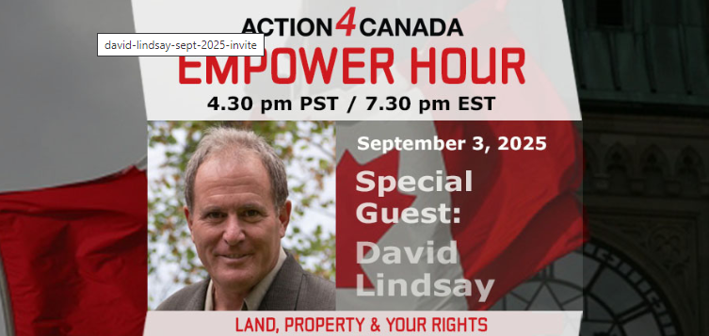
Action4Canada Empower Hour Wednesday, September 3, 2025. Zoom doors open at 4:25pm PST/7:25pm EST. Empower Hour guest segment 4:30pm PST/7:30pm EST. Be sure to Register in advance and invite others.
On the next Empower Hour David Lindsay, co-founder of Common Law Education and Rights (CLEAR), returns to provide another powerful presentation on the rights of Canadians regarding land and property. David is a regular guest on our program and has consistently equipped viewers with knowledge of the Coronation Oath, the Constitution, and other founding documents that uphold our Christian heritage and democratic freedoms.
He will connect the dots between historical guarantees of freedom and the alarming reality we face today, where corrupt political leaders, judges, and chiefs alike are attempting to dismantle centuries of legal protections. David’s teaching will provide the historical foundation and constitutional proof that these illegitimate claims and unlawful schemes cannot stand. Canadians need to know that our rights are not granted by the government—they are secured in law, inherited through tradition, and protected as our God-given, inalienable rights.
Knowledge is Power. Be sure to join us on the upcoming Empower Hour to ensure you are equipped to confront and oppose these egregious legal and constitutional violations.
----------------------
Guidelines for Peaceful Protesting/Gathering/Rallies and/or Attending Events (eg. Council Meetings, School Boards, Handing out Flyers)
https://action4canada.com/know-your-rights-guidelines
Check out A4C for some of the most successful actions and strategies available to us!

And a big thank you to Tanya for all her hard work and dedication and support for the Christian principles that founded our nation!
https://action4canada.com/
--------------------------------------
Dr. Trozzi and Ted Kuntz
Wins of the Week - #88 – Aug. 31, 2025

https://www.drtrozzi.news/p/wins-of-the-week-ep88-with-ted-kuntz?r=1ri3is
--------------------------------------



https://weunify.ticketspice.com/rc25
--------------------------------------
--------------------------------------


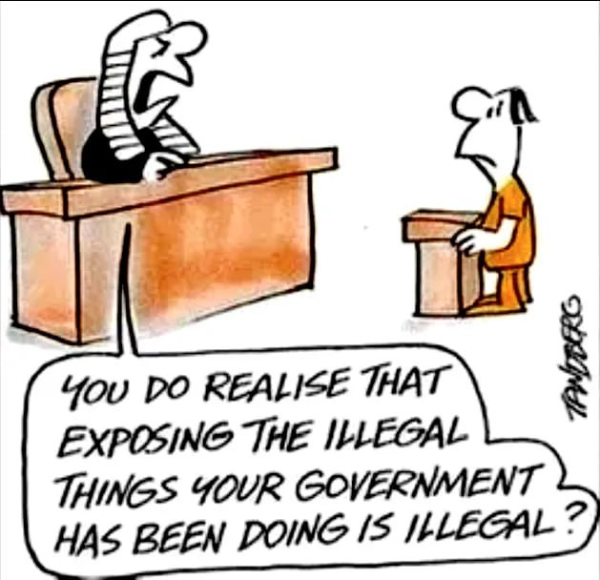
--------------------------------------

--------------------------------------

https://politicalscorecards.ca/

https://politicalscorecards.ca/election-integrity-survey-results/
--------------------------------------

--------------------------------------
chrome-extension://efaidnbmnnnibpcajpcglclefindmkaj/https://www.jccf.ca/wp-content/uploads/2023/04/Digital-ID-Surveillance-and-the-Value-of-Privacy_Justice-Centre-for-Constitutional-Freedoms.pdf
--------------------------------------

--------------------------------------


--------------------------------------



https://druthers.ca/
--------------------------------------

$$ USE OF CASH UPDATES $$
In a mixed set of updates here.
CBDC Updates:
https://libertysentinel.org/exposing-trumps-true-character/
Canadian reporter Alex Newman explains what gov’ts around the world are doing with CBDCs right now.
India: advertising about banning Bitcoin
Kuwait: Forced over 1 million citizens to hand over their bio-metric data (including fingerprints) and suspending services if they do not do so, including withdrawing or transferring money.
Date for this was Sept. 30.
35 000 bank customers suspended from using bank services

England: Bank England is preparing to force digital currencies if the banks do not do so.

93% of Central Banks in the world are working on a CBDC – this is truly frightening.

USA: House of Representatives voted to pass a bill, The Anti-Surveillance State Act, 216-192, prohibiting the Federal Reserve from issuing a CBDC. It is concerning however, many still voted against this.
Florida: Passed a law banning CBDCs!

Bruce Cain -- "Of all the various globalist agendas -- mass immigration, forced vaccination, Smart Meters, 5G, etc. -- there is no greater threat to humanity than a global digital currency. I would go so far as saying it heralds in the end of human civilization and the beginning of a dystopian global slave plantation -- completely controlled by a very small number of global oligarchs. It must be stopped.

It is important to understand that a Digital ID is a prerequisite to a Digital Currency (CBDC) as you first need to uniquely identify each human slave in a manner that can't be counterfeited. S,o while a Digital ID may include your Social Security Number it will go much further. Your Digital ID will also include things like your fingerprints, your DNA, an Iris Scan, a Facial Scan. It will be designed so there is absolutely no way to hack the system and no possibility of duplication."
-
Yet another Bank of Canada report confirms that Canadians do not want a digital currency.

Bank of Canada says digital currency doable but unpopular

https://www.westernstandard.news/news/bank-of-canada-says-digital-currency-doable-but-unpopular/65504?utm_source=newsletter&utm_medium=email&utm_term=2025-06-22&utm_campaign=Western+Standard+s+Daily+Newsletter

--------------
This is a MUST watch as Chinese refuse to use the new digital currency!
China could even ‘delete’ your money or render it ‘expired’ if not used fast enough. People are opposing it.

https://www.youtube.com/watch?app=desktop&v=N4tyqNV63KE

--------------
Support Protection of Cash Now – in Parliament!
Bill C-400
NOTE: First reading June 13, 2025.

SUMMARY
This enactment provides for the development and implementation of a framework to ensure that cash continues to be available throughout Canada.
It also amends the Currency Act and the Bank of Canada Act to remove the Governor in Council’s power to call in coins and notes. Finally, it amends the Bank of Canada Act to prohibit the Bank of Canada from issuing a digital form of the dollar.

https://www.parl.ca/documentviewer/en/44-1/bill/C-400/first-reading
https://preventgenocide2030.org/keep-cash-alive-support-bill-c-400/
--------------
France now calls for elimination of cash
Digital transactions are easier to trace, including cryptocurrencies
As usual – the same lies are relied upon: help combat drug trafficking (which gov’ts are an integral part of), and collection of taxes.
https://www.rt.com/news/618025-france-minister-ban-cash/
--------------
The Bank of Canada (B of C) has previously announced plans to suspend introduction of a Central Bank Digital Currency (CBDC) to the public.

https://www.kitco.com/news/article/2024-09-20/bank-canada-suspends-plans-introduce-cbdc-public
While this may sound victorious on its face, and there is much positive to say when such plans are shelved or put on hold, please remember the use of the word “suspend” as opposed to “cancel”.
Has the B of C simply decided to wait on the outcomes and research from other countries and then simply tag along?
In this past summer, the B of C was recommending Canada provide its own CBDC for digital payments. This apparently has been suspended or now put on hold. We can only hope for some permanency to this decision.
We need a Constitutional amendment that 100% absolutely provides for the mandatory use and acceptance of cash for all transactions – in any amount. So, if you wish to pay $1 000 000.00 for a house in $100/bills, you should be allowed to so do. That is privacy.
Conversely, Google has announced that the Google Wallet can now function as digital ID, based on the selling point of course, of convenience to the exclusion of all privacy. Once privacy is lost, so is freedom.
“Imagine starting a vacation like this,” Google Wallet executive Alan Stapelberg wrote in a blog post last week. “You arrive at the airport and breeze through security by tapping your phone to a reader, scanning your boarding pass and ID. While waiting to board, you grab a drink at an airport bar, tapping your phone to prove your age. When you arrive at your destination, you find your rental car and leave the lot without stopping for an in-person ID check because you already provided the necessary information in the rental car app. You check into your hotel online and your key is issued straight to your digital wallet. You do all of this with your phone — no physical wallet required.”
https://www.thegoldreport.com/news/google-announces-digital-id-wallet
Though a bit late, in June, 2024, Norway passed legislation requiring use of cash!
https://x.com/petersweden7/status/1843050565443395924?s=52
Yes to cash
https://x.com/jackunheard/status/1843056003497218451?s=52
--------------
In one of the most comprehensive reports to date on the issue of CBDC, the JCCF has just published: Central Bank Digital Currency? – What it is and how it could impact your privacy, security, and autonomy
https://www.jccf.ca/wp-content/uploads/2025/03/CBDC_Final-Report_March-17_Justice-Centre-for-Constitutional-Freedoms.pdf

MUST READ
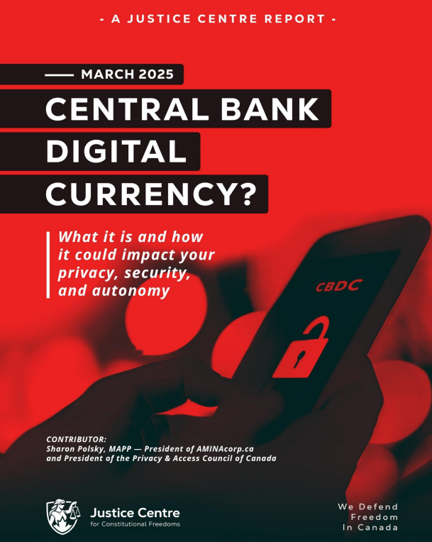
REMINDER
New Credit Card Fees & Lack of Privacy
It is starting – Use cash as much as possible – use credit cards or digital only if there is no other alternative.
The Bank of Canada is admittedly planning for digital currency. It claims that it will not replace cash – BUT – and here is the caveat, it will continue to use cash “notes for as long as Canadians want them.”

In other words, if you don’t use cash, you will lose it. Reading between the lines, it is clear that the Gov’t will simply issue press releases and polls showing most Canadians don’t use and/or don’t want cash, and then the Bank of Canada will claim it has to eliminate cash because few people are using it or want it, and it is, ironically, too costly to maintain printing the notes and coins.

https://www.bankofcanada.ca/digitaldollar/#what-digital-canadian

Bill Still, the US Patriot and author of the incredible documentary, The Money Masters, outlines the results of recent polls showing that 86% of Canadians fear the digital dollar!!! Wow.
87% of Canadians have heard or are aware of the Bank of Canada’s CBDC (Central Bank Digital Currency), and 82% are strongly opposed to it!!
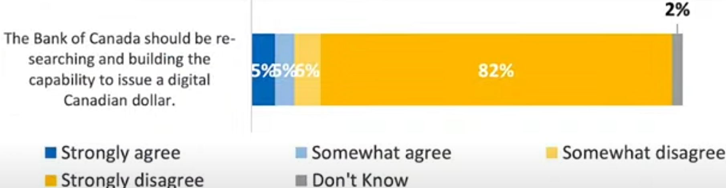

https://www.thestillreport.com/post/bank-of-canada-survey-86-fear-digital-dollar-the-still-report-episode-4280

Companies will not use digital currency if we are not using digital currency!

It will cost them too much in lost business.

Here are two awesome posters that you can distribute to all businesses to put on their entrance doors, advocating for the use of cash. Print on 8 1/2 x 11 glossy hard stock for best results.

For Business owners:
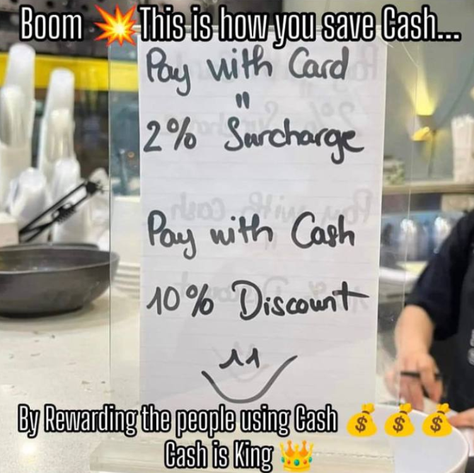
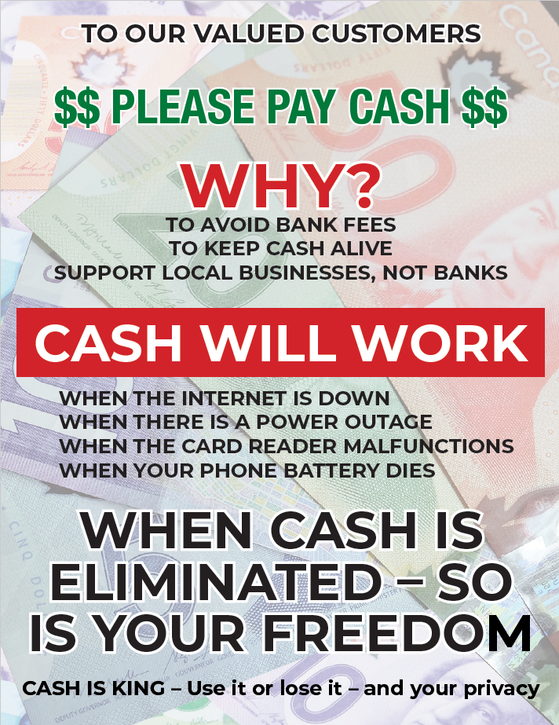
The dangers of digital gov’t ID and currencies are here… you need to use cash as much as possible. As recognized by Freedom Rising, there are many inherent dangers of using digital currency. What do you do, not if, but when:
The internet is down
There is a power outage
The card reader malfunctions
Your phone battery dies or doesn’t work for other reasons

WE SUGGEST YOU CONSIDER THE FOLLOWING AS WELL:

Your phone is stolen
Your passwords are co-opted
Your credit/debit card strip is damaged – needs replacing
There are errors in relation to the quantum of $$ on your card
Gov’t limits your purchases/CRA liens the balance on your card

AND MANY OTHER DANGERS

CLEAR has promoted the non-use of digital currencies and credit/debit cards as much as possible, for years.

Suggested Solution:
Withdraw money on Saturday/Sunday from the bank or bank machine, and then leave your money at home if you are scared to carry it with you, and just carry the amounts of cash for each day’s purchases for the week.

NO MORE CARDS!!!! NO EXCUSES!
USE CASH $$$$$$$$$

Do you want to be the next person to be “unbanked” because of your political beliefs????

Another sample: (thanks Adele)
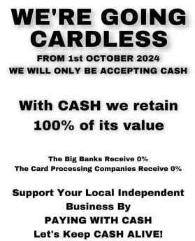


Get these cards below at the CLEAR booth to give out every time you use cash – or print your own to hand out!

Make Business sized cards to hand out at all your cash purchases!
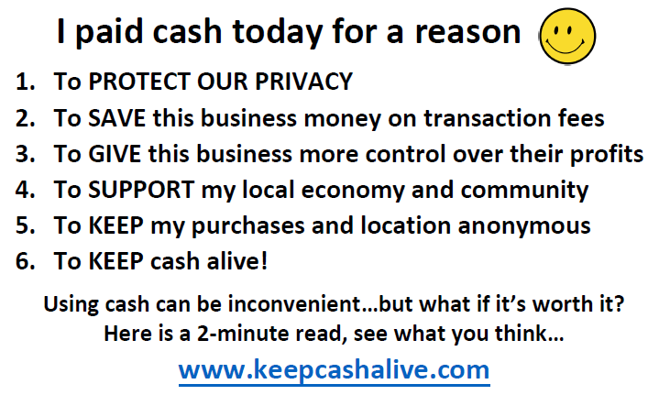

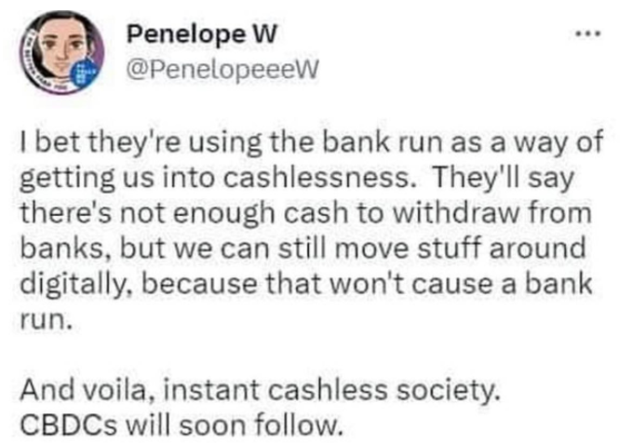

--------------------------------------


Sunday Paper Deliveries
Next delivery day:
Sunday, September 7, 2025
(Weather Permitting)
A small group of dedicated volunteers have been spreading the truth via Druthers deliveries every Sunday for over 2 years now. This is one of the most powerful things a freedom activist can do to help inform the public.

Please email us if you wish to help spread the word of Freedom!

Thank You!
--------------------------------------


--------------------------------------

Freedom Rallies

Visibility = Credibility

“It ain’t over till it’s over”

Next Kelowna Rallies:

Saturdays 12:00 noon

September 6, 2025

Your presence at public rallies/protests opposing gov’t activities – IS the message!!

September 13, 2025
Hwy 97 & Cooper

Help us give away hundreds of Druthers every week to supporting drivers and public!

September 6, 2025 12:00 noon
Vernon Freedom Rally
12:00 p.m. – 2:00 p.m. @ Polson Park
Join Ted for the Largest rally in the North Okanagan, and growing weekly!

North Okanagan Shuswap Freedom Radio
http://s1.voscast.com:11464/stream
---------------
September 6, 2025 12:00 noon
Kamloops Freedom Gathering
Valleyview Centennial Park
---------------
September 6, 2025 12:00 noon
O.K. Falls Freedom Rally
11:30 a.m.
Across from Esso Station
---------------
September 6, 2025 12:00 noon
Oliver Freedom Rally
12:00 p.m.
Town Hall
---------------------------------------
CLEAR Telegram
With almost 500 members now and growing, join us in our C.L.E.A.R. Telegram group! Please remember: no foul language, abuse or vulgarity for any posts, keep posts relevant to today’s freedom issues, humour is fine, be respectful at all times. Government officials, police, agents or their posts are not accepted nor permitted on this site. Please ensure as best you can, that material you post is accurate and correct. Posting false or incorrect information is not acceptable.
Help us ensure all posts are verified for correctness.
Opinions and discussions on relevant issues are also encouraged.
This is a private group for trusted people and friends only.
https://t.me/+SWxndPh1I9F2Iu-q

