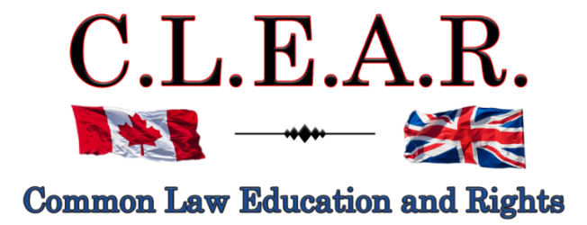

“Promoting Freedom in B.C.”
Greetings. Freedom comes in many forms, but fundamentally it all comes down to choice – your choice.
Threats to your choice to all natural heath care products and supplement are looming large on the horizon. If you are purchasing health care supplements or products of any kind, or wish to do so, or providing them, this is critical information you should be aware of.
Many of us lack the details to know what exactly is occurring. This is where Shawn Buckley is so important for us.
Please join and support Shawn on Zoom this coming Tuesday, September 23, 2025, 8:00 – 9:00 pm. EST, or 5:00-6:00 PST, by registering here:
https://us02web.zoom.us/meeting/register/XflpQEGeSG6Ud4XJAjhfdw#/registration

Shawn Buckley will also be honouring us with his presence this coming October 7, 2025 here in Kelowna, at the Events Centre, 2041 Harvey Ave., at 6:30 p.m.!

This is all part of the Health Charter Tour
The World’s Greatest Health Show.
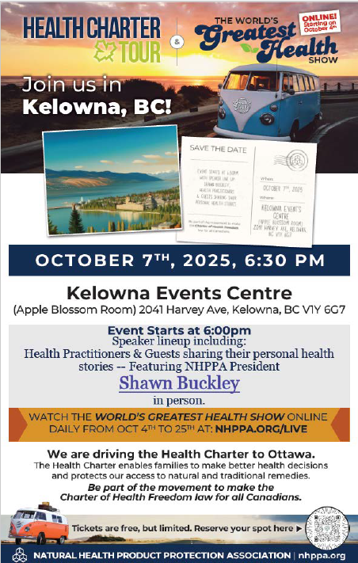
Starting on October 4th, during the Health Charter Tour, the NHPPA will be broadcasting The World's Greatest Health Show, featuring interviews with Experts and Citizens, Natural Health Product experiences and testimonials, along with featured "on the road" live events! Subscribe to the https://nhppa.org/ for more information.

Tour information can be found at:

https://nhppa.org/join-the-tour/
https://nhppa.org/health-charter-tour/#/

WE NEED YOUR HELP TO SHARE ABOUT THE WORLD'S GREAT HEALTH SHOW. Watch daily online starting Oct 4 at 7 a.m. PST for three weeks until we end up on Parliament Hill on the 25th when we present the 150k petitions to Parliament.
Share within all your own circles the downloadable on https://nhppa.org/

A must Watch: please share on all your channels:
https://www.youtube.com/watch?v=cF0QdfctpoQ

Please also see the World’s Greatest Health Charter Tour opening video
https://www.youtube.com/watch?v=4br411sMHS4
https://nhppa.org/donate/#/
See Tour Dates below and help support this incredible Canada-wide tour by informing others across the country to come out to each meeting in their location.

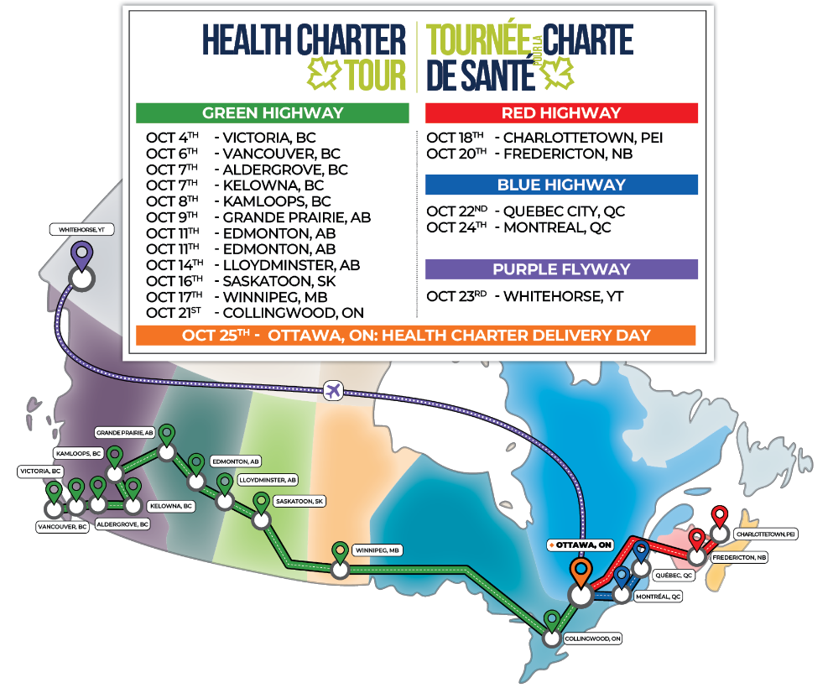
https://nhppa.org/join-the-tour/
