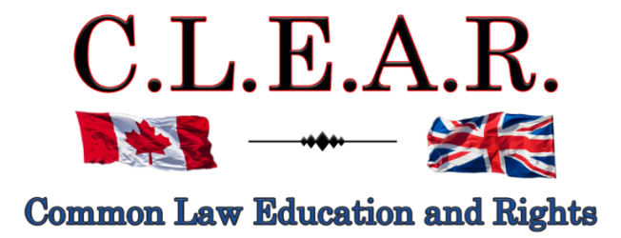

“Promoting Freedom in B.C.”
Freedom activists are critical thinkers!
Our society is so dumbed down and indoctrinated that anyone who is a critical thinker is labeled as a Conspiracy Theorist to avoid critical debates

Did you know: The term ‘conspiracy theorist’ was first coined and used by the CIA to ridicule anyone who opposed the gov’t narrative?
--------------------------------------

--------------------------------------
It is important to come out on Saturdays to oppose all Gov’t corruption and support others. Visibility = Credibility

Next rally is:
Saturday

October 4, 2025
Stuart Park!!

David Lindsay will return to the Freedom Rally with significant updates!

October 11, 2025 – Hwy 97!!

Help us give away hundreds of Druthers every week to supporting drivers and public!
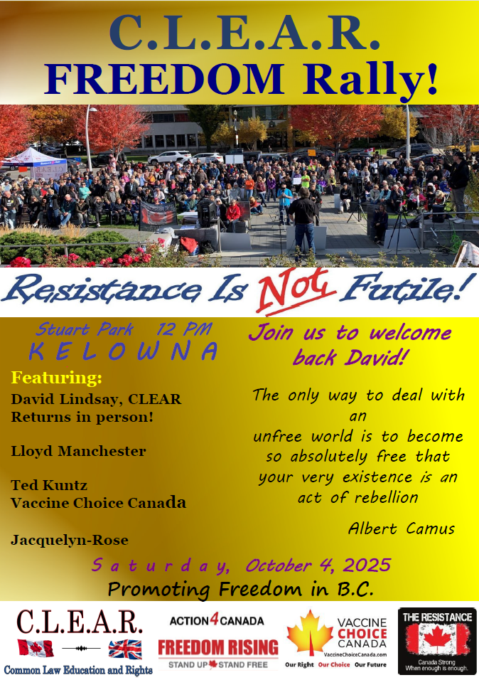
--------------------------------------
See our entire, unedited 4-part article:

Criminalizing Dissent: Suppressing Freedom of Expression in Canada here:

https://clearbc.org/clear-blog/
--------------------------------------
Courts - UPDATE

Falsified assault charge - Appeal
Kelowna Courthouse
R v David Lindsay s. 266 Criminal Code

Thank you for all your support and belief for freedom!!

Remember the Freedom Principle:

An attack against one is an attack against all.
An attack against all, is an attack against one.
--------------------------------------

--------------------------------------
Update:

Next Supreme Court Appeal Hearing Date from the falsified assault convictions against David:
Date: Week of Sept. 29, 2025 2:00 p.m.
Kelowna Courthouse

I have been now put on the back up list and I remain unsure if this hearing will take place this week or not. I will let everyone know as soon as I find out.

Issue:

Hearing on Constitutional Challenge to have Transcripts accepted that I have produced – and to rule that charging fees for Transcripts required for Trial applications and appeals is a violation of s. 7, 8 and 11 of the Charter.

I have now filed a Constitutional Challenge to the transcripts fees statutes and regulations.

The implications of this are enormous, for everyone who has had to pay tens of thousands of dollars in extortionist transcripts fees (average $1500-$2000/day!!!), in addition to lawyer’s fees.

Stay tuned on this one!
---------------------
Probation Order suspended till appeal is heard – David can now host the Freedom Rallies and publicly discuss this trial!
At sentencing last year on the falsified assault charges against me, J. Heinrichs imposed a completely unreasonable two-year probation order, prohibiting me from publicly talking about the security guards involved in the incident, including Greg Smith, the Interior Health security officer who lied directly to the police that I was causing a disturbance in support of his one-month ban against me from entering the IH building on Doyle St. in Kelowna. All of which we have on video, thanks to Leo’s diligence and dedication.

In Court recently, the Supreme Court Justice agreed to suspend the probation order until the appeal is heard sometime next year.

And this further allows me to continue our protest rallies again starting October 4.

And a big thank you to Lloyd – we were able to continue our public efforts for freedom in Kelowna. Without his amazing help over the past nine months, the people of Kelowna would have likely subscribed to the ‘out of sight, out of mind’ principle.

Please take the opportunity and express your gratitude to Lloyd when you see him for his awesome dedication and contributions over the past few years to freedom.

I will look forward to seeing our Freedom Family this coming October 4 at Stuart Park!!!

Thank you to everyone who has continued to support freedom at Stuart Park for the past five years!!!
---------------------
City of Kelowna v David Lindsay et al
Petition to Stop Rallies at Stuart Park

IMPORTANT LEGAL UPDATE
FREEDOM OF EXPRESSION CASE
FALSIFIED ASSAULT CONVICTION APPEAL

Dear Freedom Supporters:

We want to provide you with a critical update regarding our legal battle for freedom of expression.
Continuation of the hearing for our SLAPP application has concluded in late August.

Justice Hardwick has reserved judgment in this case. There is no set date for the release of her judgment.

Kelowna filed a Petition to obtain an injunction to ban our rallies throughout the entire downtown Kelowna area, the most effective areas in the City.
In turn, we filed what is known as a SLAPP application (Strategic Lawsuit against Public Participation), pursuant to the Protection of Public Participation Act. The acronym says it all – the Petition is an action designed to prohibit our public participation at Stuart Park exposing gov’t corruption and lies.
https://www.bclaws.gov.bc.ca/civix/document/id/complete/statreg/19003
We urge everyone to pray for success in this case. This type of case has never been heard in Canada and we need God on our side to ensure a precedent in our favour. Please pray that J. Hardwick will come down on the side of freedom.
Our Court documents in this case are located on our website at:

https://clearbc.org/david/
City of Kelowna documents and pleadings are now placed on our website for public viewing:

https://clearbc.org/city-of-kelowna/

Our SLAPP Application: A Strong Legal Defense
Our SLAPP Application is incredibly detailed and well-prepared. As the legal maxims state: “Fraud lurks in generalities”, and, “the details make all the difference.”
The City’s strategy is clear:
- Ignore Constitutional law and attempt to redefine protesting as a regulated activity.
- Gloss over key legal principles and hope the courts accept their broad, unfounded claims.
- Bylaw us out of existence—forcing us away from public spaces and out of the public eye.
But we refuse to be silenced.
We knew we had to be meticulously prepared, with extensive evidence and legal arguments to counter every false claim. And we are prepared.

The Broader War on Free Speech
This case is not an isolated attack—it is part of a coordinated effort to suppress free expression across Canada, particularly in British Columbia and Alberta.
- Online censorship is expanding.
- Private interest groups, funded by the government, are targeting businesses that support free speech, threatening them with boycotts and false accusations. Many businesses break contracts with us at the last minute out of fear.
- Municipal governments are being weaponized to push freedom advocates out of public spaces.
- And most recently under the Communist Liberal Government, ongoing refusals to permit certain media outlets into their press releases and government functions, to ensure only Liberal Government supported media is allowed in.
Their tactic is simple: Out of sight, out of mind. If they can erase us and our messages from public view, they believe they can stifle dissent.
Thank you for your unwavering support.
--------------------------------------
Action4Canada

Remember the Freedom Principle:

An attack against one is an attack against all.
An attack against all, is an attack against one.
----------------
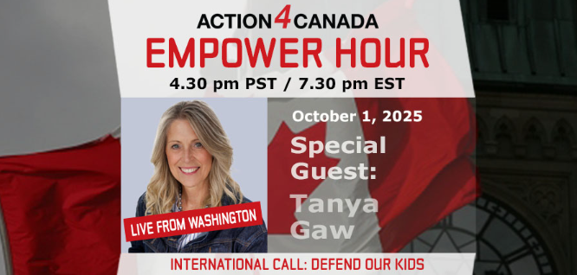
Next Empower Hour: October 1, 2025 with Tanya Gaw
Topic: Defend our Kids
Sign on starts at: 4:30 pm PST/7:30 pm EST
Pre-Register Now for this Webinar
Join us! Share this page and link with your friends and social media!
----------------------
Action4Canada files SLAPP application!
This is the second SLAPP application now filed in BC (after CLEAR Application against the City of Kelowna) against persons trying to deny freedom of expression. Please see below link for details and the PDF link for a copy of this Application!
https://action4canada.com/legal-updates-covid-19-case-and-tyson-cook-aka-drag-queen-frieda-whales-sept-2025/

chrome-extension://efaidnbmnnnibpcajpcglclefindmkaj/https://action4canada.com/wp-content/uploads/Notice-of-Application-to-dismiss-26-Sep-2026.pdf

Guidelines for Peaceful Protesting/Gathering/Rallies and/or Attending Events (eg. Council Meetings, School Boards, Handing out Flyers)
https://action4canada.com/know-your-rights-guidelines
Check out A4C for some of the most successful actions and strategies available to us!

And a big thank you to Tanya for all her hard work and dedication and support for the Christian principles that founded our nation!
https://action4canada.com/
--------------------------------------
Dr. Trozzi and Ted Kuntz
Wins of the Week - #92 – September 7, 2025

https://www.drtrozzi.news/p/wins-of-the-week-ep92-with-ted-kuntz?r=1ri3is

--------------------------------------



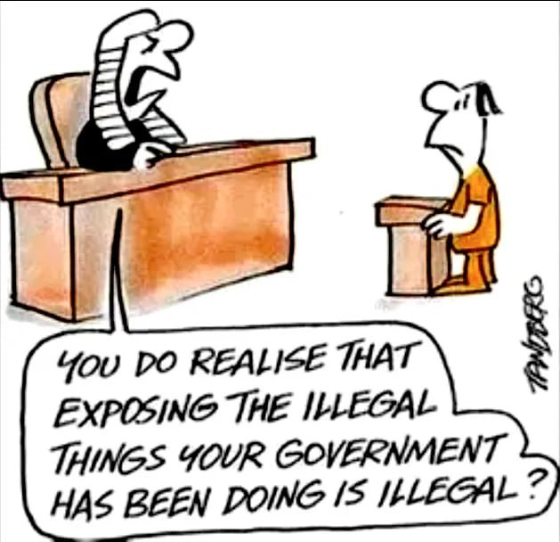
--------------------------------------

--------------------------------------

https://politicalscorecards.ca/

https://politicalscorecards.ca/election-integrity-survey-results/
--------------------------------------

--------------------------------------
chrome-extension://efaidnbmnnnibpcajpcglclefindmkaj/https://www.jccf.ca/wp-content/uploads/2023/04/Digital-ID-Surveillance-and-the-Value-of-Privacy_Justice-Centre-for-Constitutional-Freedoms.pdf
--------------------------------------

--------------------------------------


https://druthers.ca/
--------------------------------------
DIGITAL ID AND CASH UPDATES
THE PRIVACY NOOSE IS GETTING TIGHTER – USE CASH!!!!!
Remember the Gov’ts created this problem with massive immigration that was not required – mostly single men. Now it wants to solve this problem by taking your privacy away.

https://www.brighteon.com/1dd37ca9-4375-4a39-a44e-18644f41fd98


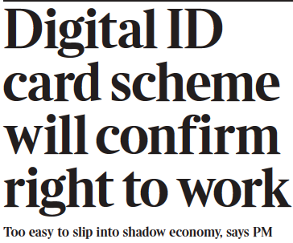
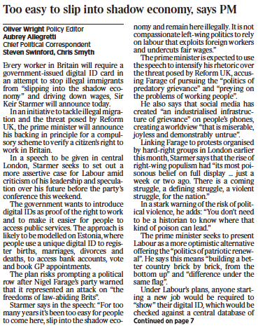
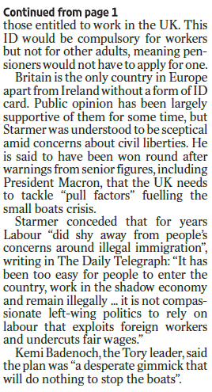
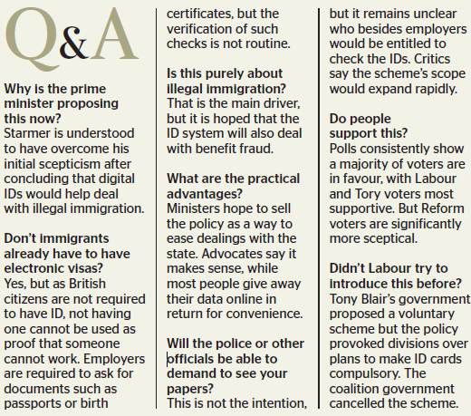

In a mixed set of updates here.
CBDC Updates:
https://libertysentinel.org/exposing-trumps-true-character/
Canadian reporter Alex Newman explains what gov’ts around the world are doing with CBDCs right now.
India: advertising about banning Bitcoin
Kuwait: Forced over 1 million citizens to hand over their bio-metric data (including fingerprints) and suspending services if they do not do so, including withdrawing or transferring money.
Date for this was Sept. 30.
35 000 bank customers suspended from using bank services

England: Bank England is preparing to force digital currencies if the banks do not do so.

93% of Central Banks in the world are working on a CBDC – this is truly frightening.

USA: House of Representatives voted to pass a bill, The Anti-Surveillance State Act, 216-192, prohibiting the Federal Reserve from issuing a CBDC. It is concerning however, many still voted against this.
Florida: Passed a law banning CBDCs!

Bruce Cain -- "Of all the various globalist agendas -- mass immigration, forced vaccination, Smart Meters, 5G, etc. -- there is no greater threat to humanity than a global digital currency. I would go so far as saying it heralds in the end of human civilization and the beginning of a dystopian global slave plantation -- completely controlled by a very small number of global oligarchs. It must be stopped.”

It is important to understand that a Digital ID is a prerequisite to a Digital Currency (CBDC) as you first need to uniquely identify each human slave in a manner that can't be counterfeited. S,o while a Digital ID may include your Social Security Number it will go much further. Your Digital ID will also include things like your fingerprints, your DNA, an Iris Scan, a Facial Scan. It will be designed so there is absolutely no way to hack the system and no possibility of duplication."
-
Yet another Bank of Canada report confirms that Canadians do not want a digital currency.

Bank of Canada says digital currency doable but unpopular

https://www.westernstandard.news/news/bank-of-canada-says-digital-currency-doable-but-unpopular/65504?utm_source=newsletter&utm_medium=email&utm_term=2025-06-22&utm_campaign=Western+Standard+s+Daily+Newsletter

--------------
This is a MUST watch as Chinese refuse to use the new digital currency!

China could even ‘delete’ your money or render it ‘expired’ if not used fast enough. People are opposing it.

https://www.youtube.com/watch?app=desktop&v=N4tyqNV63KE

--------------
France now calls for elimination of cash
Digital transactions are easier to trace, including cryptocurrencies
As usual – the same lies are relied upon: help combat drug trafficking (which gov’ts are an integral part of), and collection of taxes.
https://www.rt.com/news/618025-france-minister-ban-cash/
--------------
The Bank of Canada (B of C) has previously announced plans to suspend introduction of a Central Bank Digital Currency (CBDC) to the public.

https://www.kitco.com/news/article/2024-09-20/bank-canada-suspends-plans-introduce-cbdc-public
While this may sound victorious on its face, and there is much positive to say when such plans are shelved or put on hold, please remember the use of the word “suspend” as opposed to “cancel”.
Has the B of C simply decided to wait on the outcomes and research from other countries and then simply tag along?
In this past summer, the B of C was recommending Canada provide its own CBDC for digital payments. This apparently has been suspended or now put on hold. We can only hope for some permanency to this decision.
We need a Constitutional amendment that 100% absolutely provides for the mandatory use and acceptance of cash for all transactions – in any amount. So, if you wish to pay $1 000 000.00 for a house in $100/bills, you should be allowed to so do. That is privacy.
Conversely, Google has announced that the Google Wallet can now function as digital ID, based on the selling point of course, of convenience to the exclusion of all privacy. Once privacy is lost, so is freedom.
“Imagine starting a vacation like this,” Google Wallet executive Alan Stapelberg wrote in a blog post last week. “You arrive at the airport and breeze through security by tapping your phone to a reader, scanning your boarding pass and ID. While waiting to board, you grab a drink at an airport bar, tapping your phone to prove your age. When you arrive at your destination, you find your rental car and leave the lot without stopping for an in-person ID check because you already provided the necessary information in the rental car app. You check into your hotel online and your key is issued straight to your digital wallet. You do all of this with your phone — no physical wallet required.”
https://www.thegoldreport.com/news/google-announces-digital-id-wallet
Though a bit late, in June, 2024, Norway passed legislation requiring use of cash!
https://x.com/petersweden7/status/1843050565443395924?s=52
Yes to cash
https://x.com/jackunheard/status/1843056003497218451?s=52
--------------
In one of the most comprehensive reports to date on the issue of CBDC, the JCCF has just published: Central Bank Digital Currency? – What it is and how it could impact your privacy, security, and autonomy
https://www.jccf.ca/wp-content/uploads/2025/03/CBDC_Final-Report_March-17_Justice-Centre-for-Constitutional-Freedoms.pdf

MUST READ
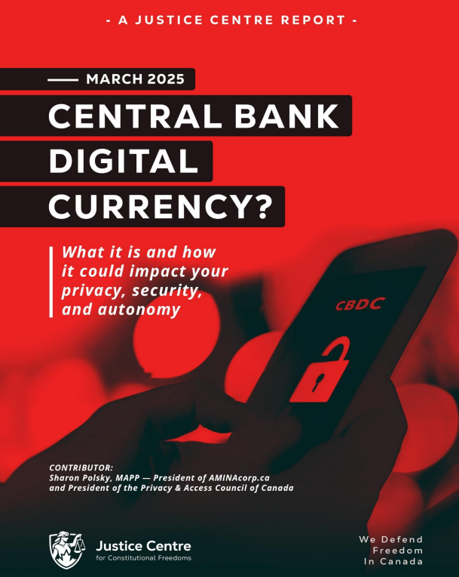
REMINDER
New Credit Card Fees & Lack of Privacy
It is starting – Use cash as much as possible – use credit cards or digital only if there is no other alternative.
The Bank of Canada is admittedly planning for digital currency. It claims that it will not replace cash – BUT – and here is the caveat, it will continue to use cash “notes for as long as Canadians want them.”

In other words, if you don’t use cash, you will lose it. Reading between the lines, it is clear that the Gov’t will simply issue press releases and polls showing most Canadians don’t use and/or don’t want cash, and then the Bank of Canada will claim it has to eliminate cash because few people are using it or want it, and it is, ironically, too costly to maintain printing the notes and coins.

https://www.bankofcanada.ca/digitaldollar/#what-digital-canadian

Bill Still, the US Patriot and author of the incredible documentary, The Money Masters, outlines the results of recent polls showing that 86% of Canadians fear the digital dollar!!! Wow.
87% of Canadians have heard or are aware of the Bank of Canada’s CBDC (Central Bank Digital Currency), and 82% are strongly opposed to it!!
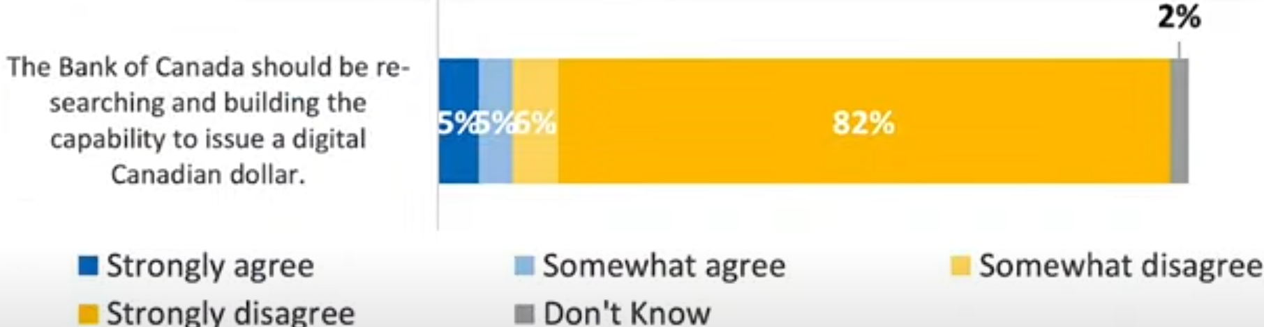

https://www.thestillreport.com/post/bank-of-canada-survey-86-fear-digital-dollar-the-still-report-episode-4280

Companies will not use digital currency if we are not using digital currency!

It will cost them too much in lost business.

Here are two awesome posters that you can distribute to all businesses to put on their entrance doors, advocating for the use of cash. Print on 8 1/2 x 11 glossy hard stock for best results.

For Business owners:
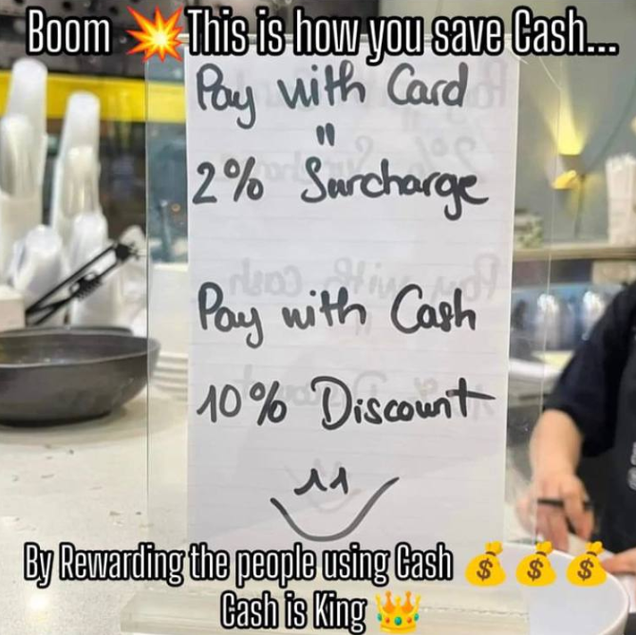
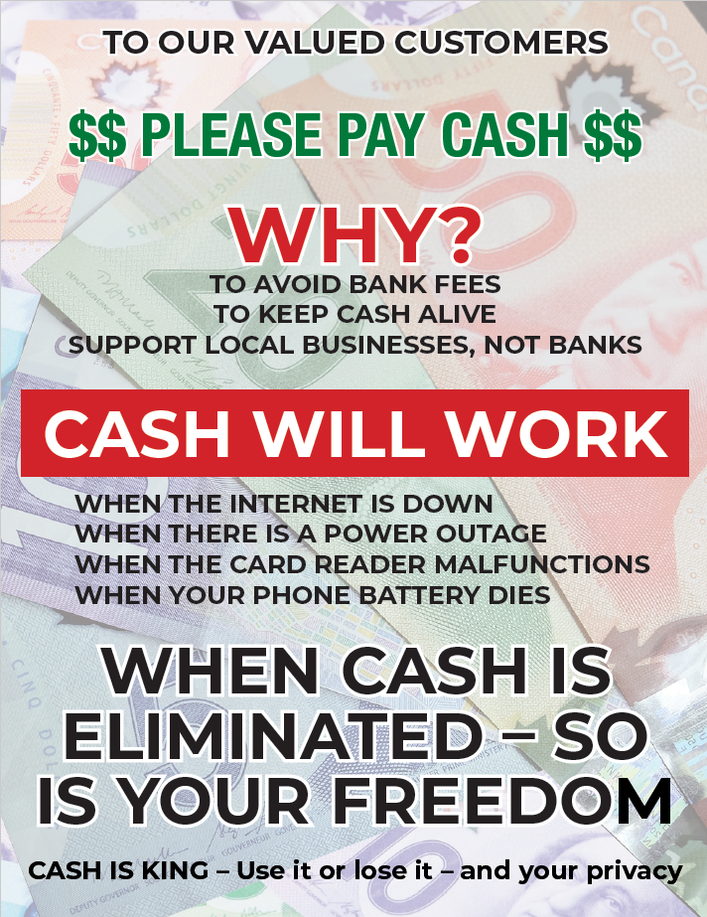
The dangers of digital gov’t ID and currencies are here… you need to use cash as much as possible. As recognized by Freedom Rising, there are many inherent dangers of using digital currency. What do you do, not if, but when:
The internet is down
There is a power outage
The card reader malfunctions
Your phone battery dies or doesn’t work for other reasons

WE SUGGEST YOU CONSIDER THE FOLLOWING AS WELL:

Your phone is stolen
Your passwords are co-opted
Your credit/debit card strip is damaged – needs replacing
There are errors in relation to the quantum of $$ on your card
Gov’t limits your purchases/CRA liens the balance on your card

AND MANY OTHER DANGERS

CLEAR has promoted the non-use of digital currencies and credit/debit cards as much as possible, for years.

Suggested Solution:
Withdraw money on Saturday/Sunday from the bank or bank machine, and then leave your money at home if you are scared to carry it with you, and just carry the amounts of cash for each day’s purchases for the week.

NO MORE CARDS!!!! NO EXCUSES!
USE CASH $$$$$$$$$

Do you want to be the next person to be “unbanked” because of your political beliefs????

Another sample: (thanks Adele)
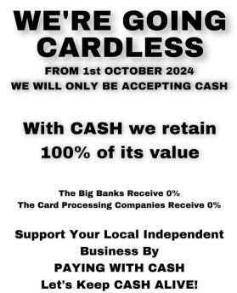
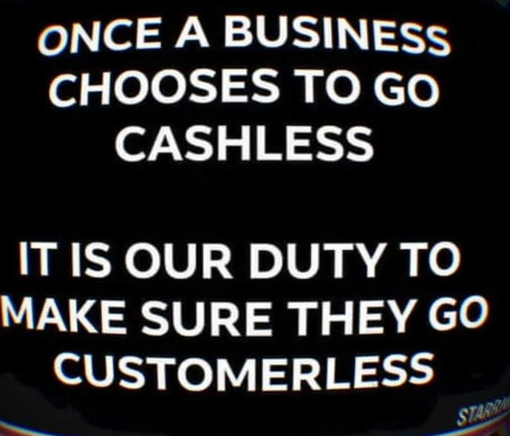

Get these cards below at the CLEAR booth to give out every time you use cash – or print your own to hand out!

Make Business sized cards to hand out at all your cash purchases!
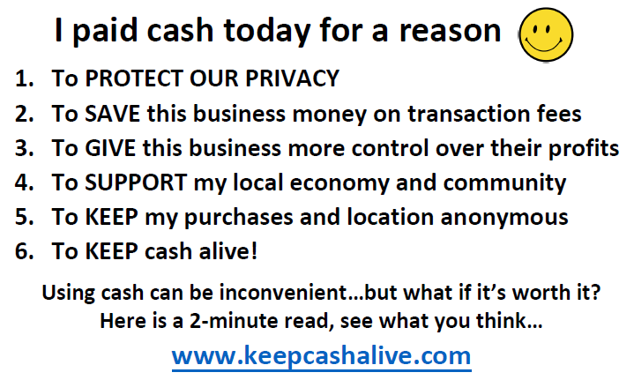

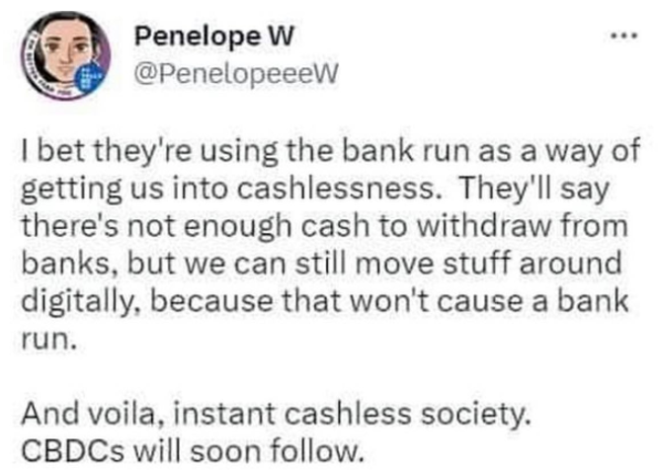

--------------------------------------


Sunday Paper Deliveries
Next delivery day:
Sunday, October 5, 2025
(Weather Permitting)
A small group of dedicated volunteers have been spreading the truth via Druthers deliveries every Sunday for over 2 years now. This is one of the most powerful things a freedom activist can do to help inform the public.

Please email us if you wish to help spread the word of Freedom!

Thank You!
--------------------------------------

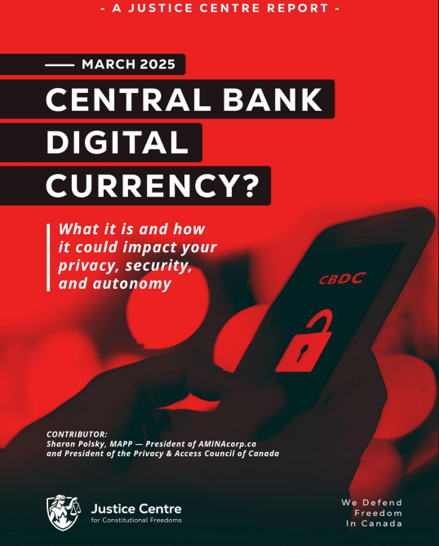
--------------------------------------

Freedom Rallies

Visibility = Credibility

“It ain’t over till it’s over”

Next Kelowna Rallies:

Saturdays 12:00 noon

October 4, 2025
Stuart Park

October 11, 2025
Hwy 97 & Cooper

Your presence at public rallies/protests opposing gov’t activities – IS the message!!

Help us give away hundreds of Druthers every week to supporting drivers and public!

October 4, 2025 12:00 noon
Vernon Freedom Rally
12:00 p.m. – 2:00 p.m. @ Polson Park
Join Ted for the Largest rally in the North Okanagan, and growing weekly!

North Okanagan Shuswap Freedom Radio
http://s1.voscast.com:11464/stream
---------------
October 4, 2025 12:00 noon
Kamloops Freedom Gathering
Valleyview Centennial Park
---------------
October 4, 2025 12:00 noon
O.K. Falls Freedom Rally
11:30 a.m.
Across from Esso Station
---------------
October 4, 2025 12:00 noon
Oliver Freedom Rally
12:00 p.m.
Town Hall
---------------------------------------
CLEAR Telegram
With almost 500 members now and growing, join us in our C.L.E.A.R. Telegram group! Please remember: no foul language, abuse or vulgarity for any posts, keep posts relevant to today’s freedom issues, humour is fine, be respectful at all times. Government officials, police, agents or their posts are not accepted nor permitted on this site. Please ensure as best you can, that material you post is accurate and correct. Posting false or incorrect information is not acceptable.
Help us ensure all posts are verified for correctness.
Opinions and discussions on relevant issues are also encouraged.
This is a private group for trusted people and friends only.
https://t.me/+SWxndPh1I9F2Iu-q

