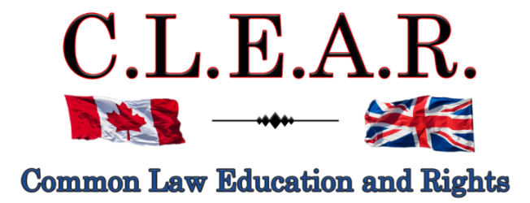

“Promoting Freedom in B.C.”
Freedom activists are critical thinkers!
Our society is so dumbed down and indoctrinated that anyone who is a critical thinker is labeled as a Conspiracy Theorist to avoid critical debates

Did you know: The term ‘conspiracy theorist’ was first coined and used by the CIA to ridicule anyone who opposed the Gov’t narrative?
--------------------------------------

--------------------------------------
It is important to come out on Saturdays to oppose all Gov’t corruption and support others.

Visibility = Credibility

Next rally is:

November 15, 2025 – Hwy 97!!

December 6, 2025
Stuart Park – Christmas Freedom Rally!!

Help us give away hundreds of Druthers every week to supporting drivers and public!
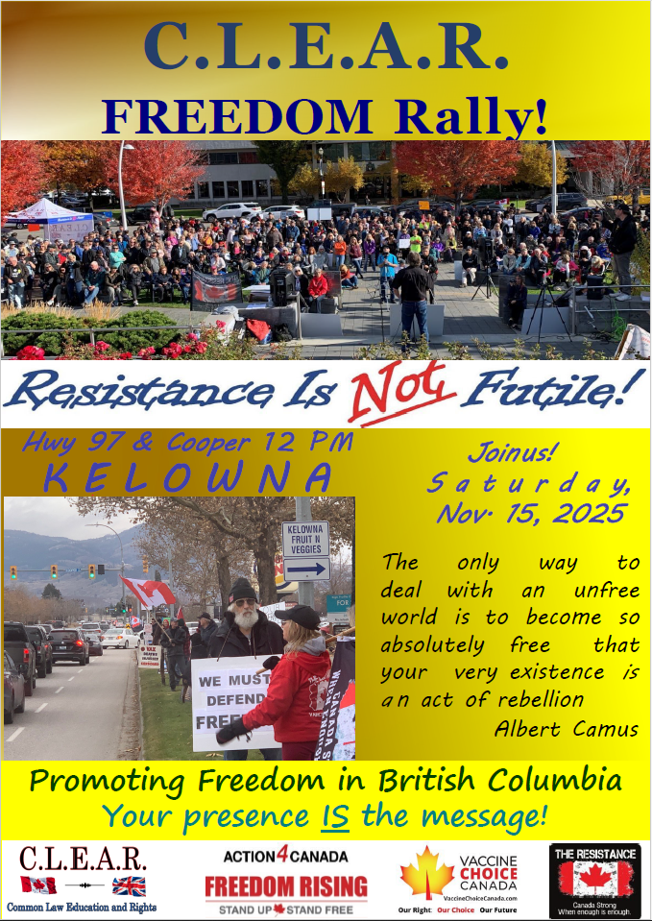
--------------------------------------
CLEAR Telegram
With hundreds of members now and growing, join us in our C.L.E.A.R. Telegram group! Please remember: no foul language, abuse or vulgarity for any posts, keep posts relevant to today’s freedom issues, humour is fine, be respectful at all times. Government officials, police, agents or their posts are not accepted nor permitted on this site. Please ensure as best you can, that material you post is accurate and correct. Posting false or incorrect information is not acceptable.
Help us ensure all posts are verified for correctness.
Opinions and discussions on relevant issues are also encouraged.
This is a private group for trusted people and friends only. If you wish to join, please email us at: clear2012@pm.me
-------------------------------------
Criminalizing Dissent: Suppressing Freedom of Expression in Canada

See our entire, unedited 4-part article:

https://clearbc.org/clear-blog/
--------------------------------------
CLEARLY Important:

Ireland to Mandate Cash Acceptance—Before the “Cashless Creep” Takes Hold

https://solarireport.substack.com/p/ireland-to-mandate-cash-acceptancebefore?r=52vtu&triedRedirect=true
--------------
The Case for Climate Realism A Q&A for Politicians, Candidates, and Voters

Climate Realists of British Columbia
https://climaterealists.ca

chrome-extension://efaidnbmnnnibpcajpcglclefindmkaj/https://climaterealists.ca/wp-content/uploads/2025/05/QA-for-Candidates-May-29-2025-short-final.pdf
--------------
Safety Above All
How the culture of “saftyism” is eroding civil liberties in Canada

chrome-extension://efaidnbmnnnibpcajpcglclefindmkaj/https://theccf.ca/wp-content/uploads/SafetyismCanadaReport.pdf
--------------
The Wildfire Myth: Historical Data Debunks Climate's Role
Dr. Matthew Wielicki – IrrationalFear.com

https://irrationalfear.substack.com/p/the-wildfire-myth-historical-data
--------------
October Recap: Exposing the Myths and Grifts in Climate Alarmism

https://irrationalfear.substack.com/p/october-recap-exposing-the-myths?img=https%3A%2F%2Fsubstack-post-media.s3.amazonaws.com%2Fpublic%2Fimages%2Fd7de104d-dd21-442e-afe0-5f9d8e0db446_1536x1024.png&open=false
--------------
CANADA’S MOST CENSORIOUS BYLAWS

chrome-extension://efaidnbmnnnibpcajpcglclefindmkaj/https://theccf.ca/wp-content/uploads/CCFs-Canadas-Most-Censorious-Bylaws-Report-2025.pdf
--------------
Liberals move ahead with digital ID for federal benefits

https://www.westernstandard.news/news/liberals-move-ahead-with-digital-id-for-federal-benefits/68810
--------------
Crown appeals conviction of peaceful Convoy leader Chris Barber

https://www.rebelnews.com/crown_seeks_harsher_sentence_for_chris_barber_a_peaceful_trucker
--------------
The Great Escape: From Banks to Silver

https://action4canada.com/financial-freedom-at-risk-why-silver-matters-now/
--------------
WATCH: UN boss demands $1.3 TRILLION in "climate justice" funding

https://www.junonews.com/p/watch-un-boss-demands-13-trillion?publication_id=3610415&post_id=178214492&triggerShare=true&isFreemail=true&r=1ri3is&triedRedirect=true
--------------
Should British Columbians have different rights to *water* based on their ancestry?

https://x.com/NVanCaroline/status/1986816555322360054
--------------
Study shows UK 'wokeness' is fading fast

https://www.westernstandard.news/international/study-shows-uk-wokeness-is-fading-fast/68864
--------------
UK's sense of division reaches new high as culture war tensions grow, study finds

https://www.kcl.ac.uk/news/uks-sense-of-division-reaches-new-high-as-culture-war-tensions-grow-study-finds
--------------
Denmark Is Fighting AI by Giving Citizens Copyright to Their Own Faces

https://www.vice.com/en/article/denmark-is-fighting-ai-by-giving-citizens-copyright-to-their-own-faces/
--------------
Read:
The Law
Frederick Bastiat
--------------------------------------
Courts - UPDATE

Falsified assault charge - Appeal
Kelowna Courthouse
R v David Lindsay s. 266 Criminal Code

Thank you for all your support and belief for freedom!!

Remember the Freedom Principle:

An attack against one is an attack against all.
An attack against all, is an attack against one.
--------------------------------------

--------------------------------------
FALSIFIED ASSAULT CONVICTION APPEAL
Update - Success:

Next hearing date will be on November 17, 2025.

At my previous hearing in September, it was agreed that if the A.G. were to consent to my friend Twyla, a Gov’t certified transcriber, producing my Transcripts, we did not need to argue my Constitutional Challenge as this would then be moot.

On Monday, November 3, 2025, J. Wilson ordered that Twyla can produce my Transcripts required for this appeal, despite having no contract with the Province to do so!!!!

This is a major victory in opening the door to having future transcribers produce Transcripts for appeal purposes, even at no cost to the accused!!

This is the foot in the door to the eventual judicial recognition that we are entitled to Transcripts as of right on appeals. This remains to be determined in some other case, but it will be raised again at some point in the future.
Meanwhile, it is a good victory that Twyla, a certified court transcriber who also believes in freedom, can produce my Transcripts for this appeal. The actual appeal date will not be set until later this year or in January, but it will not be till likely in the summer of 2026.

Thanks to God for this important success!

---------------------
Probation Order suspended till appeal is heard – David can now host the Freedom Rallies and publicly discuss this trial!
At sentencing last year on the falsified assault charges against me, J. Heinrichs imposed a completely unreasonable two-year probation order, prohibiting me from publicly talking about the security guards involved in the incident, including Greg Smith, the Interior Health security officer who lied directly to the police that I was causing a disturbance in support of his one-month ban against me from entering the IH building on Doyle St. in Kelowna. All of which we have on video, thanks to Leo’s diligence and dedication.

In Court recently, the Supreme Court Justice agreed to suspend the probation order until the appeal is heard sometime next year.

And this further allows me to continue our Freedom Rallies again!

NOTE: The City of Kelowna has once again started issuing me tickets for holding our Constitutionally protected Freedom Rallies. Their position is that we need a licence to do so. This case will likely wind up, once again on freedom of expression, in the Supreme Court of Canada.
-------------------
City of Kelowna v David Lindsay et al
Petition to Stop Rallies at Stuart Park

IMPORTANT LEGAL UPDATE
FREEDOM OF EXPRESSION CASE
Dear Freedom Supporters:
We want to provide you with a critical update regarding our legal battle for freedom of expression.

Continuation of the hearing for our SLAPP application has concluded in late August.

Justice Hardwick has reserved judgment in this case. There is no set date for the release of her judgment.

Kelowna filed a Petition to obtain an injunction to ban our rallies throughout the entire downtown Kelowna area, the most effective areas in the City.

In turn, we filed what is known as a SLAPP application (Strategic Lawsuit against Public Participation), pursuant to the Protection of Public Participation Act. The acronym says it all – the Petition is an action designed to prohibit our public participation at Stuart Park exposing gov’t corruption and lies.
https://www.bclaws.gov.bc.ca/civix/document/id/complete/statreg/19003
We urge everyone to pray for success in this case. This type of case has never been heard in Canada and we need God on our side to ensure a precedent in our favour. Please pray that J. Hardwick will come down on the side of freedom.
Our Court documents in this case are located on our website at:

https://clearbc.org/david/
City of Kelowna documents and pleadings are now placed on our website for public viewing:

https://clearbc.org/city-of-kelowna/

Our SLAPP Application: A Strong Legal Defense
Our SLAPP Application is incredibly detailed and well-prepared. As the legal maxims state: “Fraud lurks in generalities”, and, “the details make all the difference.”
The City’s strategy is clear:
- Ignore Constitutional law and attempt to redefine protesting as a regulated activity.
- Gloss over key legal principles and hope the courts accept their broad, unfounded claims.
- Bylaw us out of existence—forcing us away from public spaces and out of the public eye.
But we refuse to be silenced.
We knew we had to be meticulously prepared, with extensive evidence and legal arguments to counter every false claim. And we are prepared.

The Broader War on Free Speech
This case is not an isolated attack—it is part of a coordinated effort to suppress free expression across Canada, particularly in British Columbia and Alberta.
- Online censorship is expanding.
- Private interest groups, funded by the government, are targeting businesses that support free speech, threatening them with boycotts and false accusations. Many businesses break contracts with us at the last minute out of fear.
- Municipal governments are being weaponized to push freedom advocates out of public spaces.
- And most recently under the Communist Liberal Government, ongoing refusals to permit certain media outlets into their press releases and government functions, to ensure only Liberal Government supported media is allowed in.

Their tactic is simple: Out of sight, out of mind. If they can erase us and our messages from public view, they believe they can stifle dissent.
Thank you for your unwavering support.
--------------------------------------
Action4Canada

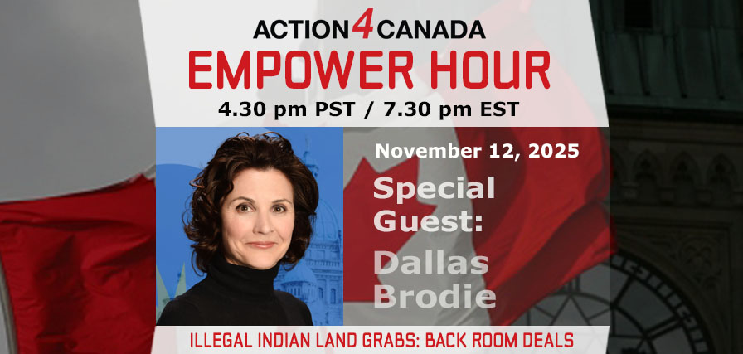

Next Empower Hour: November 12, 2025

Special Guest: Dallas Brodie

Topic: Illegal Indian Land Grabs: Back Room Deals

Wednesday November 12, 2025. Zoom doors open at 4:25pm PST/7:25pm EST. Empower Hour guest segment 4:30pm PST/7:30pm EST.

Register in Advance and invite others.
Join us! Share this page and link with your friends and social media!
Action4Canada Empower Hour Wednesday, November 12, 2025. Zoom doors open at 4:25pm PST/7:25pm EST. Empower Hour guest segment 4:30pm PST/7:30pm EST. Be sure to Register in advance and invite others.

Join Tanya Gaw and special guest BC MLA Dallas Brodie, the fearless Conservative voice behind Bill 19 to ban divisive land acknowledgments and stop DRIPA-fueled land theft. Together they will expose how corrupt governments and globalist elites weaponize Indian land claims to strip hardworking Canadian families of their rightful property.
Unmasking the DRIPA trap: British Columbia’s 2019 provincial version of UNDRIP, United Nations Declaration for the Rights of Indigenous People, attempts to fill the void left by the absence of province-wide treaties—with only limited historic exceptions like the Douglas Treaties on Vancouver Island and Treaty 8 in the northeast. This unlawful “shared decision-making” scheme—enabled by activist judges misinterpreting the Constitution—seeks to override all private property rights without consent, targeting landowners near key water resources (oceans, rivers, and lakes) for mass land, mineral and natural resource grabs. These actions violate the Crown’s Coronation Oath, a binding covenant to govern Canada under Protestant Christian faith and biblical principles.

- Deuteronomy 7:2 warns: “When you enter a land, make no covenant with them.” DRIPA defies this command.

- Proverbs 22:28 commands: “Do not remove the ancient landmark.” Globalists are seeking to erase boundaries established by our Christian forefathers.

This is Klaus Schwab’s “You’ll own nothing” agenda in action: exploiting ‘unceded’ land loopholes and fabricated title to dismantle private property, seize natural resources, collapse rural Canada, and replace sovereignty with technocratic control.

Action4Canada stands with property owners and patriots—speaking truth, exposing corruption and mobilizing Canadians to defend our land, our liberty and our legacy.

Truth cannot be silenced. You can’t afford to miss this critical Empower Hour—stand with us and demand justice.
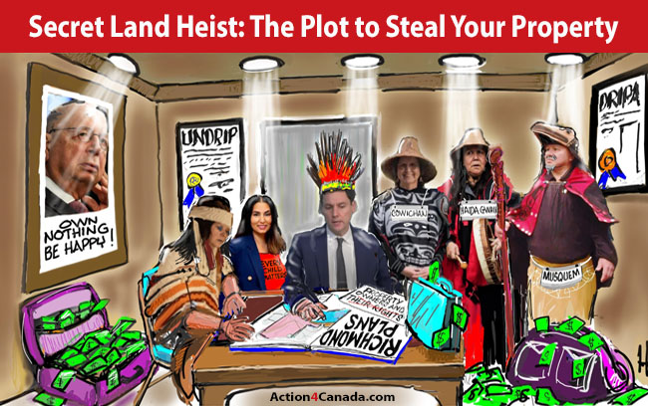

Remember the Freedom Principle:

An attack against one is an attack against all.
An attack against all, is an attack against one.
----------------
Action4Canada files SLAPP application!
This is the second SLAPP application now filed in BC (after CLEAR Application against the City of Kelowna) against persons trying to deny freedom of expression against those of us supporting freedom, family and faith issues. Please see below link for details and the PDF link for a copy of this Application!
https://action4canada.com/legal-updates-covid-19-case-and-tyson-cook-aka-drag-queen-frieda-whales-sept-2025/

chrome-extension://efaidnbmnnnibpcajpcglclefindmkaj/https://action4canada.com/wp-content/uploads/Notice-of-Application-to-dismiss-26-Sep-2026.pdf

Guidelines for Peaceful Protesting/Gathering/Rallies and/or Attending Events (eg. Council Meetings, School Boards, Handing out Flyers)
https://action4canada.com/know-your-rights-guidelines
Check out A4C for some of the most successful actions and strategies available to us!

And a big thank you to Tanya for all her hard work and dedication and support for the Christian principles that founded our nation!
https://action4canada.com/
--------------------------------------
Dr. Trozzi and Ted Kuntz
Wins of the Week - #97 – November 2, 2025

https://www.drtrozzi.news/p/wins-of-the-week-ep97-with-ted-kuntz?publication_id=1972999&post_id=177732651&isFreemail=true&r=1ri3is&triedRedirect=true
--------------------------------------

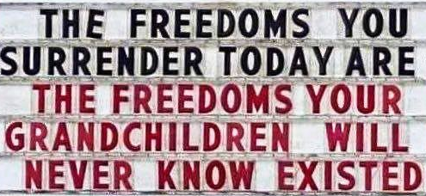

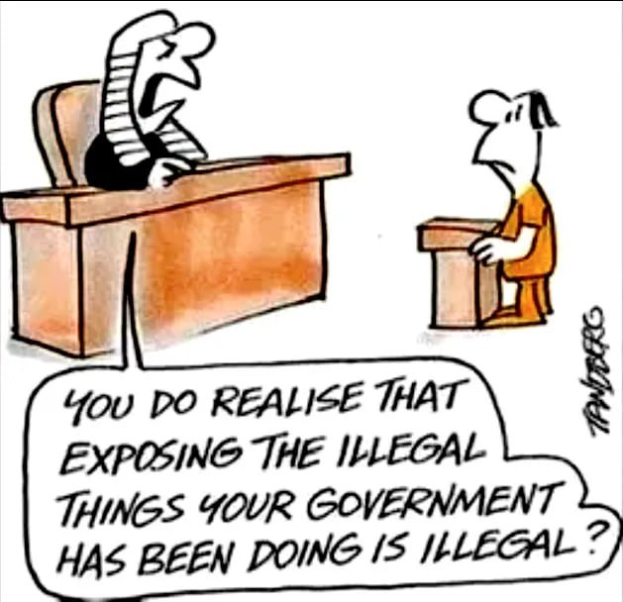
--------------------------------------

--------------------------------------

https://politicalscorecards.ca/

https://politicalscorecards.ca/election-integrity-survey-results/
--------------------------------------

--------------------------------------
chrome-extension://efaidnbmnnnibpcajpcglclefindmkaj/https://www.jccf.ca/wp-content/uploads/2023/04/Digital-ID-Surveillance-and-the-Value-of-Privacy_Justice-Centre-for-Constitutional-Freedoms.pdf
--------------------------------------

--------------------------------------

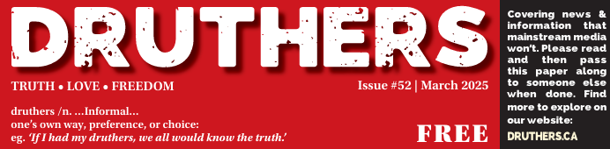
https://druthers.ca/
--------------------------------------
DIGITAL ID AND CASH UPDATES
THE PRIVACY NOOSE IS GETTING TIGHTER – USE CASH!!!!!

https://clearbc.org/cash-cards/

Remember the Gov’ts created this problem with massive immigration that was not required – mostly single men. Now it wants to solve this
problem by taking your privacy away
https://www.brighteon.com/1dd37ca9-4375-4a39-a44e-18644f41fd98


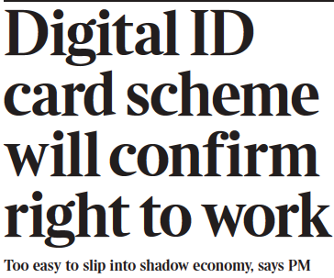

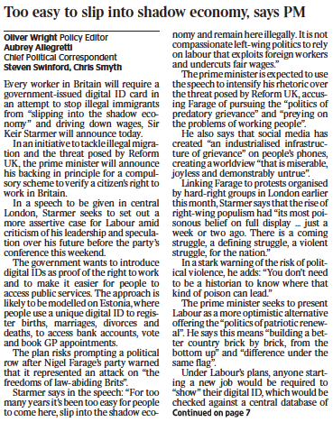
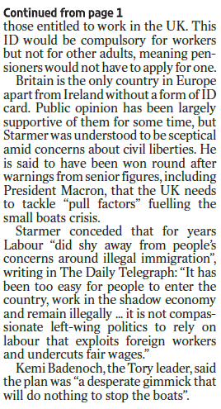
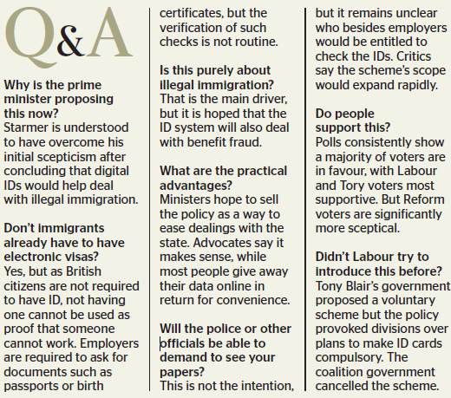

In a mixed set of updates here.
CBDC Updates:
https://libertysentinel.org/exposing-trumps-true-character/
Canadian reporter Alex Newman explains what gov’ts around the world are doing with CBDCs right now.
India: advertising about banning Bitcoin
Kuwait: Forced over 1 million citizens to hand over their bio-metric data (including fingerprints) and suspending services if they do not do so, including withdrawing or transferring money.
Date for this was Sept. 30.
35 000 bank customers suspended from using bank services

England: Bank England is preparing to force digital currencies if the banks do not do so.

93% of Central Banks in the world are working on a CBDC – this is truly frightening.

USA: House of Representatives voted to pass a bill, The Anti-Surveillance State Act, 216-192, prohibiting the Federal Reserve from issuing a CBDC. It is concerning however, many still voted against this.
Florida: Passed a law banning CBDCs!

Bruce Cain -- "Of all the various globalist agendas -- mass immigration, forced vaccination, Smart Meters, 5G, etc. -- there is no greater threat to humanity than a global digital currency. I would go so far as saying it heralds in the end of human civilization and the beginning of a dystopian global slave plantation -- completely controlled by a very small number of global oligarchs. It must be stopped.”

It is important to understand that a Digital ID is a prerequisite to a Digital Currency (CBDC) as you first need to uniquely identify each human slave in a manner that can't be counterfeited. S,o while a Digital ID may include your Social Security Number it will go much further. Your Digital ID will also include things like your fingerprints, your DNA, an Iris Scan, a Facial Scan. It will be designed so there is absolutely no way to hack the system and no possibility of duplication."
-
Yet another Bank of Canada report confirms that Canadians do not want a digital currency.

Bank of Canada says digital currency doable but unpopular

https://www.westernstandard.news/news/bank-of-canada-says-digital-currency-doable-but-unpopular/65504?utm_source=newsletter&utm_medium=email&utm_term=2025-06-22&utm_campaign=Western+Standard+s+Daily+Newsletter

--------------
This is a MUST watch as Chinese refuse to use the new digital currency!

China could even ‘delete’ your money or render it ‘expired’ if not used fast enough. People are opposing it.

https://www.youtube.com/watch?app=desktop&v=N4tyqNV63KE

--------------
France now calls for elimination of cash
Digital transactions are easier to trace, including cryptocurrencies
As usual – the same lies are relied upon: help combat drug trafficking (which gov’ts are an integral part of), and collection of taxes.
https://www.rt.com/news/618025-france-minister-ban-cash/
--------------
The Bank of Canada (B of C) has previously announced plans to suspend introduction of a Central Bank Digital Currency (CBDC) to the public.

https://www.kitco.com/news/article/2024-09-20/bank-canada-suspends-plans-introduce-cbdc-public
While this may sound victorious on its face, and there is much positive to say when such plans are shelved or put on hold, please remember the use of the word “suspend” as opposed to “cancel”.
Has the B of C simply decided to wait on the outcomes and research from other countries and then simply tag along?
In this past summer, the B of C was recommending Canada provide its own CBDC for digital payments. This apparently has been suspended or now put on hold. We can only hope for some permanency to this decision.
We need a Constitutional amendment that 100% absolutely provides for the mandatory use and acceptance of cash for all transactions – in any amount. So, if you wish to pay $1 000 000.00 for a house in $100/bills, you should be allowed to so do. That is privacy.
Conversely, Google has announced that the Google Wallet can now function as digital ID, based on the selling point of course, of convenience to the exclusion of all privacy. Once privacy is lost, so is freedom.
“Imagine starting a vacation like this,” Google Wallet executive Alan Stapelberg wrote in a blog post last week. “You arrive at the airport and breeze through security by tapping your phone to a reader, scanning your boarding pass and ID. While waiting to board, you grab a drink at an airport bar, tapping your phone to prove your age. When you arrive at your destination, you find your rental car and leave the lot without stopping for an in-person ID check because you already provided the necessary information in the rental car app. You check into your hotel online and your key is issued straight to your digital wallet. You do all of this with your phone — no physical wallet required.”
https://www.thegoldreport.com/news/google-announces-digital-id-wallet
Though a bit late, in June, 2024, Norway passed legislation requiring use of cash!
https://x.com/petersweden7/status/1843050565443395924?s=52
Yes to cash
https://x.com/jackunheard/status/1843056003497218451?s=52
--------------
In one of the most comprehensive reports to date on the issue of CBDC, the JCCF has just published: Central Bank Digital Currency? – What it is and how it could impact your privacy, security, and autonomy
https://www.jccf.ca/wp-content/uploads/2025/03/CBDC_Final-Report_March-17_Justice-Centre-for-Constitutional-Freedoms.pdf

MUST READ
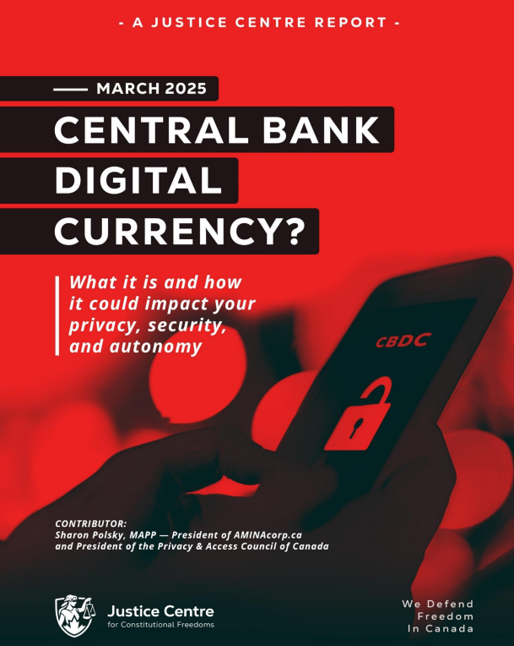
REMINDER
New Credit Card Fees & Lack of Privacy
It is starting – Use cash as much as possible – use credit cards or digital only if there is no other alternative.

The Bank of Canada is admittedly planning for digital currency. It claims that it will not replace cash – BUT – and here is the caveat, it will continue to use cash “notes for as long as Canadians want them.”

In other words, if you don’t use cash, you will lose it. Reading between the lines, it is clear that the Gov’t will simply issue press releases and polls showing most Canadians don’t use and/or don’t want cash, and then the Bank of Canada will claim it has to eliminate cash because few people are using it or want it, and it is, ironically, too costly to maintain printing the notes and coins.

https://www.bankofcanada.ca/digitaldollar/#what-digital-canadian

Bill Still, the US Patriot and author of the incredible documentary, The Money Masters, outlines the results of recent polls showing that 86% of Canadians fear the digital dollar!!! Wow.
87% of Canadians have heard or are aware of the Bank of Canada’s CBDC (Central Bank Digital Currency), and 82% are strongly opposed to it!!
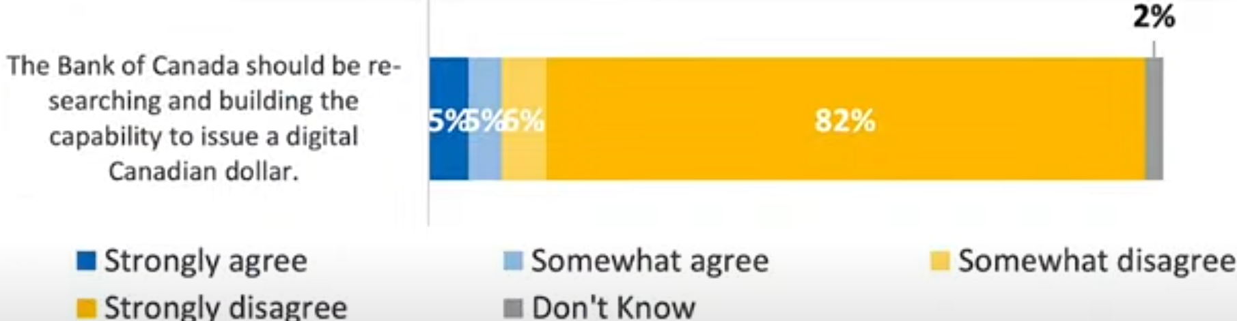

https://www.thestillreport.com/post/bank-of-canada-survey-86-fear-digital-dollar-the-still-report-episode-4280

Companies will not use digital currency if we are not using digital currency!

It will cost them too much in lost business.

Here are two awesome posters that you can distribute to all businesses to put on their entrance doors, advocating for the use of cash. Print on 8 1/2 x 11 glossy hard stock for best results.

For Business owners:
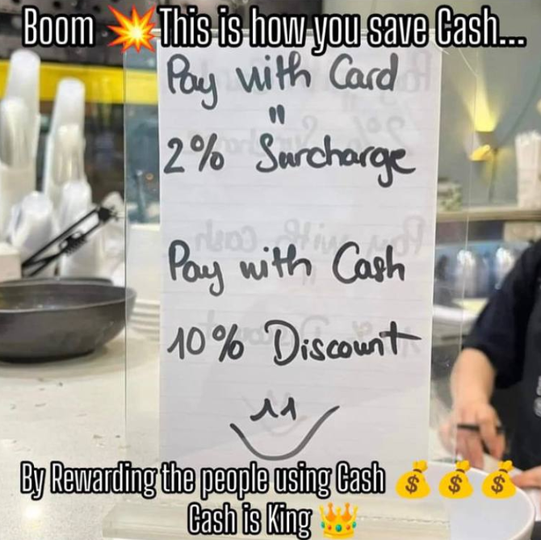
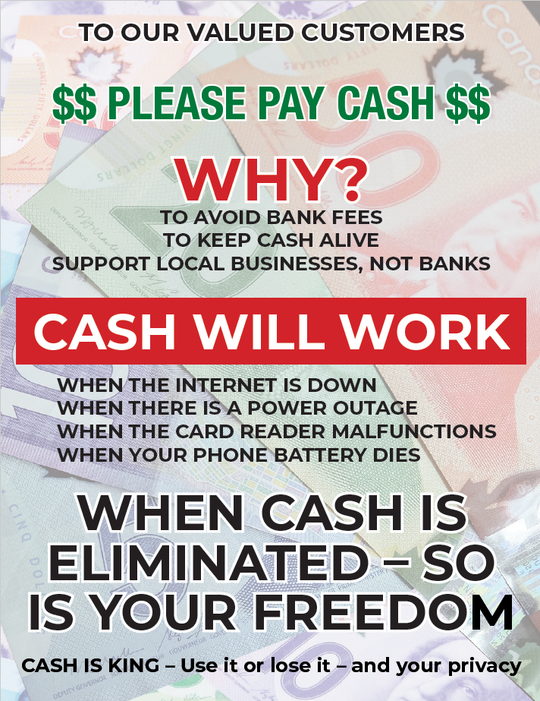
The dangers of digital gov’t ID and currencies are here… you need to use cash as much as possible. As recognized by Freedom Rising, there are many inherent dangers of using digital currency. What do you do, not if, but when:
The internet is down
There is a power outage
The card reader malfunctions
Your phone battery dies or doesn’t work for other reasons

WE SUGGEST YOU CONSIDER THE FOLLOWING AS WELL:

Your phone is stolen
Your passwords are co-opted
Your credit/debit card strip is damaged – needs replacing
There are errors in relation to the quantum of $$ on your card
Gov’t limits your purchases/CRA liens the balance on your card

AND MANY OTHER DANGERS

CLEAR has promoted the non-use of digital currencies and credit/debit cards as much as possible, for years.

Suggested Solution:
Withdraw money on Saturday/Sunday from the bank or bank machine, and then leave your money at home if you are scared to carry it with you, and just carry the amounts of cash for each day’s purchases for the week.

NO MORE CARDS!!!! NO EXCUSES!
USE CASH $$$$$$$$$

Do you want to be the next person to be “unbanked” because of your political beliefs????

Another sample: (thanks Adele)
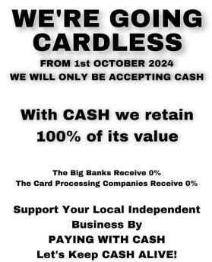
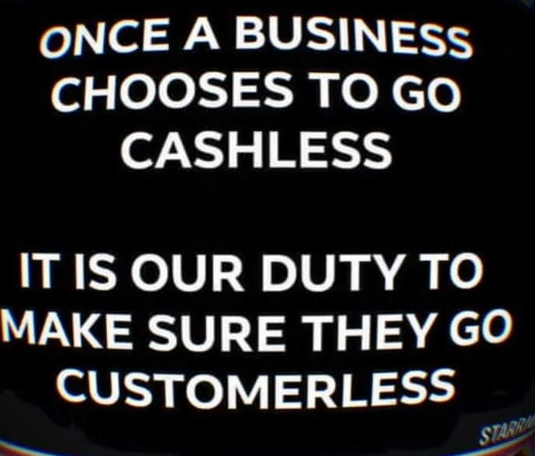

Get these cards below at the CLEAR booth to give out every time you use cash – or print your own to hand out!

Make Business sized cards to hand out at all your cash purchases!
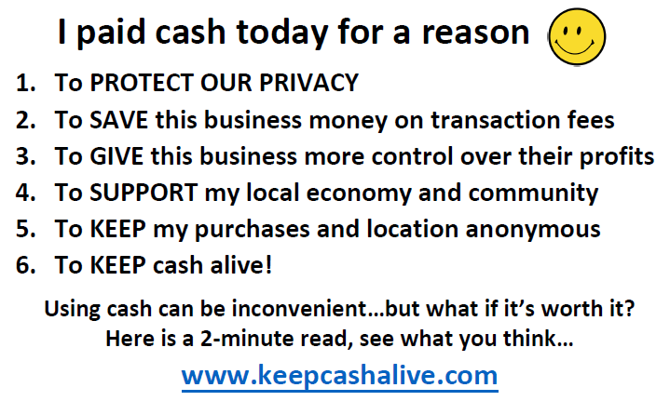

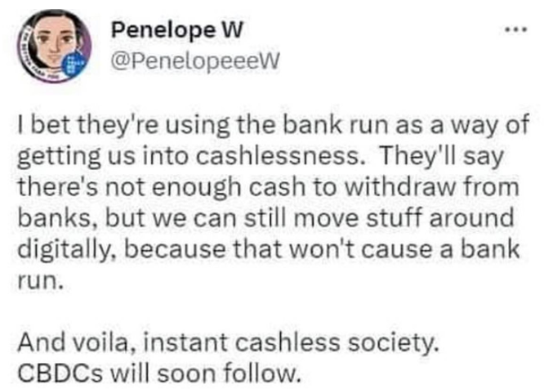

--------------------------------------

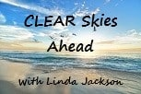
Sunday Paper Deliveries
Next delivery day:
Sunday, November 16, 2025
(Weather Permitting)
A small group of dedicated volunteers have been spreading the truth via Druthers deliveries every Sunday for over 2 years now. This is one of the most powerful things a freedom activist can do to help inform the public.

Please email us if you wish to help spread the word of Freedom!

Thank You!
--------------------------------------
Freedom Rallies

Visibility = Credibility

“It ain’t over till it’s over”

Next Kelowna Rallies:

Saturdays 12:00 noon

November 15, 2025
Hwy 97 & Cooper

December 6, 2025
Stuart Park – Christmas Freedom Rally!

Your presence at public rallies/protests opposing gov’t activities – IS the message!!

Help us give away hundreds of Druthers every week to supporting drivers and public!

November 15, 2025 12:00 noon
Vernon Freedom Rally
12:00 p.m. – 2:00 p.m. @ Polson Park
Join Ted for the Largest rally in the North Okanagan, and growing weekly!

North Okanagan Shuswap Freedom Radio
http://s1.voscast.com:11464/stream
---------------
November 15, 2025 12:00 noon
Kamloops Freedom Gathering
Valleyview Centennial Park
---------------
November 15, 2025 12:00 noon
O.K. Falls Freedom Rally
11:30 a.m.
Across from Esso Station
---------------
November 15, 2025 12:00 noon
Oliver Freedom Rally
12:00 p.m.
Town Hall

