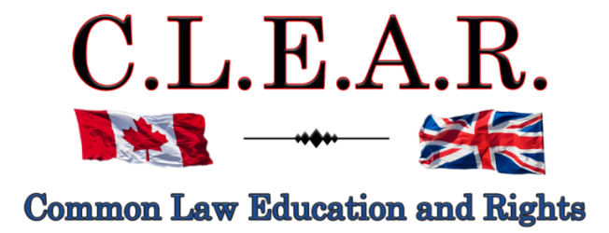

“Promoting Freedom in B.C.”
Freedom activists are critical thinkers!
Our society is so dumbed down and indoctrinated that anyone who is a critical thinker is labeled as a Conspiracy Theorist to avoid critical debates

Did you know: The term ‘conspiracy theorist’ was first coined and used by the CIA to ridicule anyone who opposed the Gov’t narrative?
--------------------------------------

--------------------------------------
It is important to come out on Saturdays to oppose all Gov’t corruption and support others.

Visibility = Credibility Your presence is the message!

Next Freedom Rally is:

December 6, 2025
Stuart Park – Christmas Freedom Rally!!

December 13, 2025 – Hwy 97!!

Help us give away hundreds of Druthers every week to supporting drivers and public!

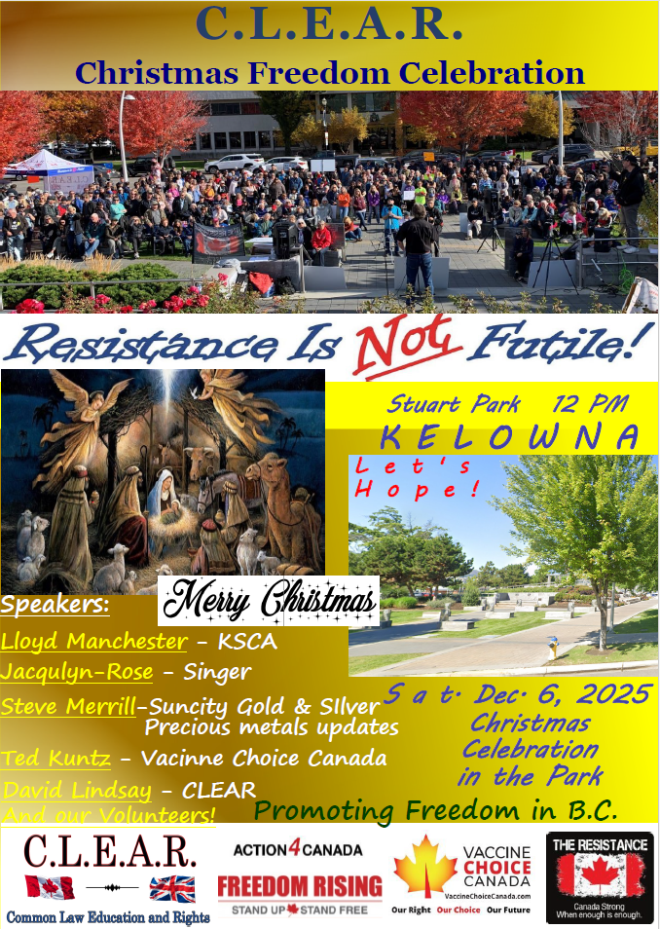
--------------------------------------

Bring your messages of Christmas hope, freedom and love, you wish to share from the stage!

Stuart Park, Kelowna
December 6, 2025
12:00 p.m.
--------------------------------------
CLEAR Telegram
With hundreds of members now and growing, join us in our C.L.E.A.R. Telegram group! Please remember: no foul language, abuse or vulgarity for any posts, keep posts relevant to today’s freedom issues, humour is fine, be respectful at all times. Government officials, police, agents or their posts are not accepted nor permitted on this site. Please ensure as best you can, that material you post is accurate and correct. Posting false or incorrect information is not acceptable.
Help us ensure all posts are verified for correctness.
Opinions and discussions on relevant issues are also encouraged.
This is a private group for trusted people and friends only. If you wish to join, please email us at: clear2012@pm.me
-------------------------------------
Criminalizing Dissent: Suppressing Freedom of Expression in Canada

See our entire, unedited 4-part article:

https://clearbc.org/clear-blog/
--------------------------------------
CLEARLY Important:

MPs and MLAs who cross the floor after being elected, should be forced into a by-election.
They were elected on a certain party platform and then fraudulently go to the other side.
David Eby recently conceded that he received a call from the Judiciary advising him that the decision in the Cowichan Indian case was not going to affect private property ownership. Clearly the NDP is instructing the Constitutionally required “independent” judiciary how to rule on certain cases – including on the SOGI issues.
Should British Columbians have different rights to *water* based on their ancestry? The BC NDP government’s Water Security Strategy recognizes First Nations as “first water users” with “priority rights.”
--------------
The poisoned chalice — the ‘anti-woke’ bill that actually authorizes woke rule
A legal expert explains how [Alberta’s] Bill 13’s hidden clauses empower regulators, muzzle professionals, and turn neutrality into a poisoned chalice.

https://www.westernstandard.news/opinion/blackett-the-poisoned-chalice-the-anti-woke-bill-that-actually-authorizes-woke-rule/69413
--------------
IS CANADA NEXT: The speech-law epidemic infecting the globe
Bill C-9 dilutes the definition and "shifts from detestation and vilification to detestation or vilification, and it removes the requirement for extremeness."

https://www.westernstandard.news/news/is-canada-next-the-speech-law-epidemic-infecting-the-globe/69236

--------------
Former VGH vascular surgeon and UBC professor York Hsiang explains why BC’s health-care crisis is about to get worse.

https://podcasts.apple.com/ca/podcast/185-bcs-healthcare-is-about-to-get-worse-with-york-hsiang/id1506974121?i=1000738349136
--------------
Ontario plans to require bail cash up front as part of new justice bill

https://globalnews.ca/news/11540677/ontario-bail-legislation-cash-up-front/

NOTE: Though this may sound good, remember bail is a Constitutional right – they reverse this right into a privilege – bail should be determined not on whether someone has cash or not – but on the likelihood of re-offending and/or seriousness of the offence. It is the judiciary who continually make the wrong decisions, then problems develop and Gov’ts come in to save the day with more draconian legislation that takes all our rights and freedoms away.
--------------
Read:
Dead Wrong: How Canada Got the Residential School Story So Wrong
https://www.amazon.ca/dp/B0G3994C3F?bestFormat=true

Civil Disobedience
Henry David Thoreau
--------------------------------------
Courts - UPDATE

Falsified assault charge - Appeal
Kelowna Courthouse
R v David Lindsay s. 266 Criminal Code

Thank you for all your support and belief for freedom!!

Remember the Freedom Principle:

An attack against one is an attack against all.
An attack against all, is an attack against one.
--------------------------------------

--------------------------------------
FALSIFIED ASSAULT CONVICTION APPEAL
Update - Success:
I will be back in court this week (Dec. 1) to set dates next year for the actual hearing of my appeal, and all issues I am raising. Some include:

Judge Heinrichs was clearly biased against me
s. 265 of the Criminal Code is overbroad and vague to permit mere touching to constitute a criminal offence
Judge Heinrichs erred in not letting my transcriber do the transcripts for my Jordan Application for delay – at this time over three months late
The RCMP Act is ultra vires Parliament - policing is a Provincial matter
The security guards, on video, assaulted me
Security Manager Greg Smith lied to the police and in court

On Monday, November 3, 2025, J. Wilson ordered that Twyla can produce my Transcripts required for this appeal, despite having no contract with the Province to do so!!!!

This is a major victory in opening the door to having future transcribers produce Transcripts for appeal purposes, even at no cost to the accused!!

This is the foot in the door to the eventual judicial recognition that we are entitled to Transcripts as of right on appeals. This remains to be determined in some other case, but it will be raised again at some point in the future.
Meanwhile, it is a good victory that Twyla, a certified court transcriber who also believes in freedom, can produce my Transcripts for this appeal. The actual appeal date will not be set until later this year or in January, but it will not be till likely in the summer of 2026.

Thanks to God for this important success!

---------------------
Probation Order suspended till appeal is heard – David can now host the Freedom Rallies and publicly discuss this trial!
At sentencing last year on the falsified assault charges against me, J. Heinrichs imposed a completely unreasonable two-year probation order, prohibiting me from publicly talking about the security guards involved in the incident, including Greg Smith, the Interior Health security officer who lied directly to the police that I was causing a disturbance in support of his one-month ban against me from entering the IH building on Doyle St. in Kelowna. All of which we have on video, thanks to Leo’s diligence and dedication.

In Court recently, the Supreme Court Justice agreed to suspend the probation order until the appeal is heard sometime next year.

And this further allows me to continue our Freedom Rallies again!

NOTE: The City of Kelowna has once again started issuing me tickets for holding our Constitutionally protected Freedom Rallies. Their position is that we need a licence to do so. This case will likely wind up, once again on freedom of expression, in the Supreme Court of Canada.
-------------------
City of Kelowna v David Lindsay et al
Petition to Stop Rallies at Stuart Park

IMPORTANT LEGAL UPDATE
FREEDOM OF EXPRESSION CASE
Dear Freedom Supporters:

We want to provide you with a critical update regarding our legal battle for freedom of expression.

Continuation of the hearing for our SLAPP application has concluded in late August.
Justice Hardwick has reserved judgment in this case. There is no set date for the release of her judgment.

Kelowna filed a Petition to obtain an injunction to ban our rallies throughout the entire downtown Kelowna area, the most effective areas in the City.

In turn, we filed what is known as an anti-SLAPP application pursuant to the Protection of Public Participation Act. The acronym (SLAPP - Strategic Lawsuit against Public Participation), says it all – the Petition is a SLAPP action intended to prohibit our public participation at Stuart Park exposing gov’t corruption and lies. We applied to have it struck.
https://www.bclaws.gov.bc.ca/civix/document/id/complete/statreg/19003
We urge everyone to pray for success in this case. This type of case has never been heard in Canada and we need God on our side to ensure a precedent in our favour. Please pray that J. Hardwick will come down on the side of freedom.
Our Court documents in this case are located on our website at:

https://clearbc.org/david/
City of Kelowna documents and pleadings are now placed on our website for public viewing:

https://clearbc.org/city-of-kelowna/

Our anti-SLAPP Application: A Strong Legal Defense
Our anti-SLAPP Application is incredibly detailed and well-prepared. As the legal maxims state: “Fraud lurks in generalities”, and, “the details make all the difference.”
The City’s strategy is clear:
- Ignore Constitutional law and attempt to redefine protesting as a regulated activity.
- Gloss over key legal principles and hope the courts accept their broad, unfounded claims.
- Bylaw us out of existence—forcing us away from public spaces and out of the public eye.
But we refuse to be silenced.
We knew we had to be meticulously prepared, with extensive evidence and legal arguments to counter every false claim. And we are prepared.

The Broader War on Free Speech
This case is not an isolated attack—it is part of a coordinated effort to suppress free expression across Canada, particularly in British Columbia and Alberta.
- Online censorship is expanding.
- Private interest groups, funded by the government, are targeting businesses that support free speech, threatening them with boycotts and false accusations. Many businesses break contracts with us at the last minute out of fear.
- Municipal governments are being weaponized to push freedom advocates out of public spaces.
- And most recently under the Communist Liberal Government, ongoing refusals to permit certain media outlets into their press releases and government functions, to ensure only Liberal Government supported media is allowed in.

Their tactic is simple: Out of sight, out of mind. If they can erase us and our messages from public view, they believe they can stifle dissent.
Thank you for your unwavering support.
--------------------------------------
Action4Canada

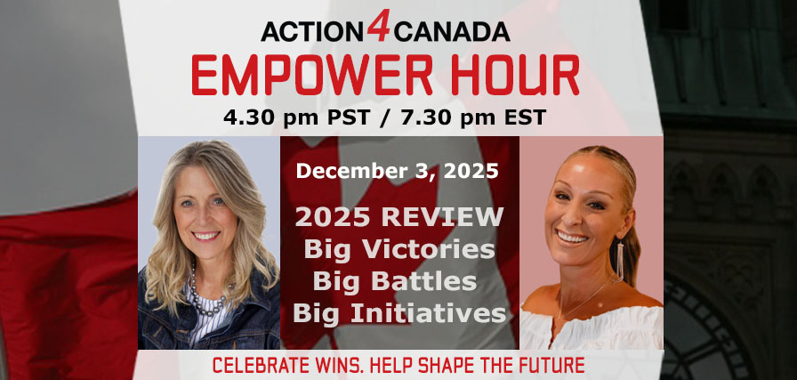
Next Empower Hour: December 3, 2025

Special Guest: Danielle Pistilli

Topic: 2025 Review: Big Victories, Big Battles, Big Initiatives

Sign on starts at: 4:30pm PST/7:30pm EST

Pre-Register Now for this Webinar
Join us! Share this page and link with your friends and social media!

Register in Advance and invite others.
This week on the Empower Hour, the mic flips! For the first time, Tanya Gaw—founder of Action4Canada and the steady force behind the movement—moves from host to guest as Danielle Pistilli steps into the interview seat.
In this special, Danielle asks the questions our members have never heard before. The interview offers a genuine look behind the scenes of building and leading a national grassroots movement—balancing long days, big decisions, ongoing responsibilities at home, and the personal sacrifices that often go unseen.

Viewers will hear from Tanya in a more personal and reflective way than ever before—honest, grounded, and motivating. It’s a timely reminder of what dedicated leadership looks like, proving how much is possible when committed citizens stand united, and offering an honest, motivating look at why this movement exists and what it takes to keep building something that truly serves Canadians.

As Action4Canada has grown, so has the weight Tanya has carried. Yet through it all, she has built an incredible team who together have created practical tools for Canadians, crafted strategies that challenge harmful policies, and equipped citizens to stand up for their rights, families, and freedoms. This episode pulls back the curtain on the courage, grit, and faith required to keep a movement alive—even when the burden is carried quietly.

And woven through the conversation is a question for every Canadian watching: In a time when pressures are rising and freedoms feel fragile, how are we each using our time, talents, and treasures to make a difference? Not everyone has funds to spare in an economy this tight—but many have skills, connections, platforms, or a voice that can strengthen the mission. This interview invites viewers to reflect, engage, and consider how they can stand alongside the one who has been standing in the gap for them, day in and day out. Don’t miss this groundbreaking episode—one that promises to challenge, encourage, and ignite something powerful in all who tune in.

Wednesday December 3, 2025. Zoom doors open at 4:25pm PST/7:25pm EST. Empower Hour guest segment 4:30pm PST/7:30pm EST. Register in Advance and invite others.



Be sure to register for this Empower Hour—you won’t want to miss it. For this special episode, Tanya has prepared a 2025 Year in Review report that reflects the extraordinary reach and impact of what Canadians have accomplished through Action4Canada. Thanks to our donors and the tireless work of our volunteers, chapter leaders, and core team, we’ve turned opposition into outcomes and challenges into measurable wins. What you see here is only a teaser of the bigger story. On December 3, Tanya will break it down live for our members who stand on the frontlines with us. After the show, the full report will be released to the public—shared far and wide to inspire more Canadians nationwide to stand, act, and push back with purpose.

Together, we are standing firm, taking strategic action, and proving what courageous, united citizens can accomplish. In 2025, Action4Canada and our Chapters rallied communities, activated national campaigns, and amplified Calls to Action to defend Faith, Family and Freedom—refusing to back down, refusing to stay silent. As we move toward 2026, the mission is expanding: more campaigns, more influence, more momentum. But movements that change the course of a nation require continuous financial backing. Your support today builds our strength for tomorrow—fueling the strategies and campaigns needed to defend Canada’s freedoms, our children, our heritage, and the nation we love.

Will you stand with us today? Every dollar you give powers real change: from mobilizing more Call to Actions equipping Canadians and amplifying truth in the public square. Whether a one time gift or monthly partnership, your generosity multiplies our impact and helps us press forward—because freedom doesn’t defend itself.

Remember the Freedom Principle:

An attack against one is an attack against all.
An attack against all, is an attack against one.
----------------
Action4Canada files SLAPP application!
This is the second SLAPP application now filed in BC (after CLEAR Application against the City of Kelowna) against persons trying to deny freedom of expression against those of us supporting freedom, family and faith issues. Please see below link for details and the PDF link for a copy of this Application!
https://action4canada.com/legal-updates-covid-19-case-and-tyson-cook-aka-drag-queen-frieda-whales-sept-2025/

chrome-extension://efaidnbmnnnibpcajpcglclefindmkaj/https://action4canada.com/wp-content/uploads/Notice-of-Application-to-dismiss-26-Sep-2026.pdf
Guidelines for Peaceful Protesting/Gathering/Rallies and/or Attending Events (eg. Council Meetings, School Boards, Handing out Flyers)
https://action4canada.com/know-your-rights-guidelines
Check out A4C for some of the most successful actions and strategies available to us!

And a big thank you to Tanya for all her hard work and dedication and support for the Christian principles that founded our nation!
https://action4canada.com/
--------------------------------------
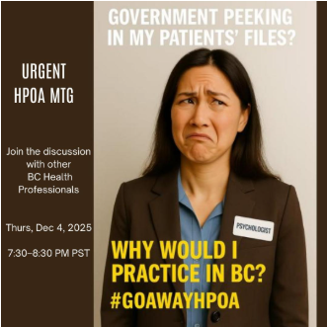
Thursday December 4th, 2025 at 7:30pm PST
Health Professions and Occupations Act (HPOA)
Discussion Continued!
Health Professionals are leaving their professions due to this act

Join the HPOA Zoom Meeting and share this link with your network:
https://us02web.zoom.us/j/89975784688?pwd=BluiGSGxfBuicpYrbVaDa4D9K9jbaF.1

CALL TO ACTION!
Join the conversation, get the facts and ask questions and take action
April 1st is the implementation date - gathering information now is critical

Critical action is needed to get thousands of regulated health professionals to complete the anonymous survey and voice their concerns to Dr. Anna Kindy who will speak to this in the legislature in February.

We are looking for a few leaders from each health profession to help us reach others to connect and learn about what HPOA is and what we can do.
*Email Carole if you would like to connect and help out: caroleanderson2468@gmail.com

Dr. Anna Kindy, MLA and Health Critic, is looking for emails from:

1.) Patients and professionals who are concerned about the HPOA - in your emails please put in the subject line: "HPOA Concerns"

2.) Stories and letters of all regulated professionals who have either already left their profession as well as those who plan to leave their profession, leave BC, or change their practice due to HPOA - subject: "I am leaving my BC Profession due to HPOA"

Health Professional Survey - For ALL Regulated Health Professionals - See link below
https://docs.google.com/forms/d/e/1FAIpQLScud30CsHMkSczEpSHofV-V5LGJ7chrpWTcMwo5mFLFLfs72g/viewform?usp=header

If you are a previous, current or soon to be regulated health care professional in BC, please fill out the survey to evaluate the impact of the implementation of the HPOA to professionals.
Actions You Can Do NOW

Step One: Complete the survey - Goal is thousands of professionals, of all areas, to respond: https://docs.google.com/forms/d/e/1FAIpQLScud30CsHMkSczEpSHofV-V5LGJ7chrpWTcMwo5mFLFLfs72g/viewform?usp=header

Step Two: Share the above survey with all of your colleagues.

Step Three: Email your concerns regarding the HPOA to Anna Kindy - MLA and Health Critic Anna.Kindy.MLA@leg.bc.ca *Subject: HPOA CONCERNS in the subject line

Step Four: Email if you have a planned exit - If you are leaving the profession then please write Anna Kindy Anna.Kindy.MLA@leg.bc.ca *Subject: I am leaving due to the HPOA in the subject line

Step Five: Join Drs. York Hsiang and Carole Anderson and other professionals on the HPOA call Thursday December 4th 7:30-8:30. Your patients will thank you!
https://us02web.zoom.us/j/89975784688?pwd=BluiGSGxfBuicpYrbVaDa4D9K9jbaF.1

The next HPOA Meeting is planned in the New Year on January 8th, 2025 7:30pm. Attend and invite others using the same zoom link above. A reminder will be sent but please save the date.

**Next email will have MORE survey results to share - here are the original first results so far:

Survey results so far with responses from only 25% of BC Psychologists so far: Survey context:

- There are 1,579 psychologists in BC.
- Approximately 388 completed the survey — many others not likely aware of the issues.
Personal & Professional Risk:
- 262 respondents (67.53%) are extremely or very concerned about personal/professional risk under the HPOA.
- Concerns include: expanded misconduct definitions, harsher disciplinary processes, higher fines, possible prison, reputational harm, and greater investigatory powers.
Impact on Professional Wellbeing:
- 371 respondents (95.61%) are concerned or very concerned the HPOA will harm their wellbeing (stress, job satisfaction, mental health).
Leaving or Reducing Practice:
- 262 (67.53%) are likely or very likely to stop practising in BC, retire early, or move to another jurisdiction.
- Among 126 intending to stay, 45 (35.71%) expect to reduce or change caseloads.
Leaving the Profession:
- 189 (48.71%) are likely or very likely to change careers or retire earlier than planned.
Defensive Practice:
- 365 (94.1%) expect to engage in more defensive practice (driven by risk avoidance rather than client needs).
Impact on Clients & Collaboration:
- 361 (93.04%) expect decreased patient trust.
- 370 (95.36%) expect decreased client willingness to share sensitive information.
- 333 (85.82%) expect poorer client mental health outcomes.
- 228 (58.76%) expect to consult less often or with fewer colleagues.

HOPA info: College of Physicians and Surgeons: https://www.cpsbc.ca/news/update-health-professions-and-occupations-act-and-professional-regulations
--------------------------------------
Dr. Trozzi and Ted Kuntz
Wins of the Week - #101 – November 30, 2025

https://www.drtrozzi.news/p/wins-of-the-week-ep101-with-ted-kuntz?r=1ri3is
--------------------------------------
https://druthers.ca/
------------------------------------



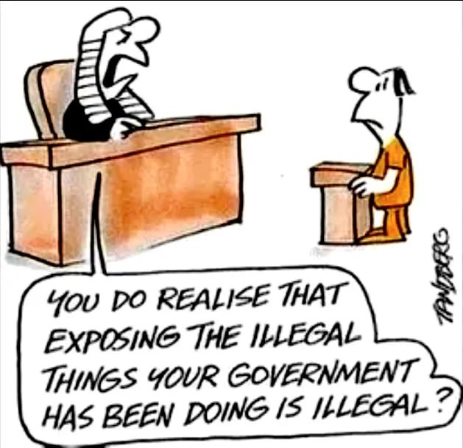
--------------------------------------

--------------------------------------

https://politicalscorecards.ca/

https://politicalscorecards.ca/election-integrity-survey-results/
--------------------------------------

--------------------------------------
chrome-extension://efaidnbmnnnibpcajpcglclefindmkaj/https://www.jccf.ca/wp-content/uploads/2023/04/Digital-ID-Surveillance-and-the-Value-of-Privacy_Justice-Centre-for-Constitutional-Freedoms.pdf
--------------------------------------
DIGITAL ID AND CASH UPDATES
THE PRIVACY NOOSE IS GETTING TIGHTER – USE CASH!!!!!

https://clearbc.org/cash-cards/

Remember the Gov’ts created this problem with massive immigration that was not required – mostly single men. Now it wants to solve this
problem by taking your privacy away
https://www.brighteon.com/1dd37ca9-4375-4a39-a44e-18644f41fd98


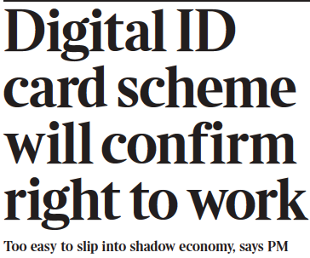
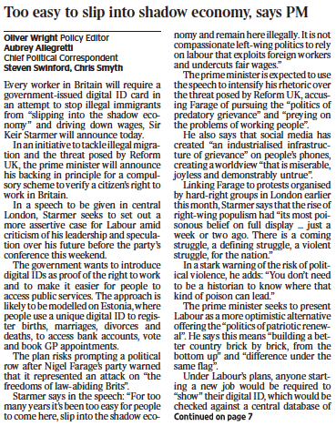
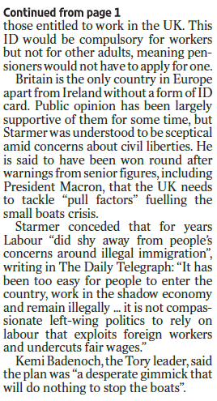
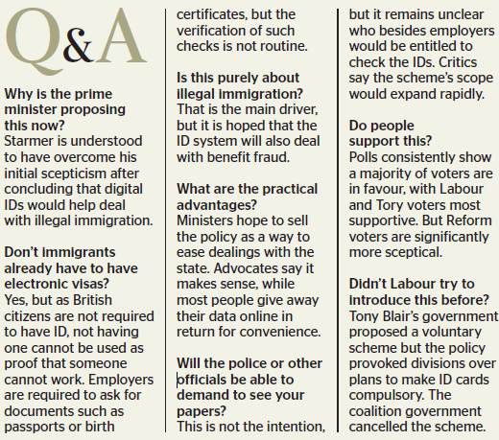

In a mixed set of updates here.
CBDC Updates:
https://libertysentinel.org/exposing-trumps-true-character/
Canadian reporter Alex Newman explains what gov’ts around the world are doing with CBDCs right now.
India: advertising about banning Bitcoin
Kuwait: Forced over 1 million citizens to hand over their bio-metric data (including fingerprints) and suspending services if they do not do so, including withdrawing or transferring money.
Date for this was Sept. 30.
35 000 bank customers suspended from using bank services

England: Bank England is preparing to force digital currencies if the banks do not do so.

93% of Central Banks in the world are working on a CBDC – this is truly frightening.

USA: House of Representatives voted to pass a bill, The Anti-Surveillance State Act, 216-192, prohibiting the Federal Reserve from issuing a CBDC. It is concerning however, many still voted against this.
Florida: Passed a law banning CBDCs!

Bruce Cain -- "Of all the various globalist agendas -- mass immigration, forced vaccination, Smart Meters, 5G, etc. -- there is no greater threat to humanity than a global digital currency. I would go so far as saying it heralds in the end of human civilization and the beginning of a dystopian global slave plantation -- completely controlled by a very small number of global oligarchs. It must be stopped.”

It is important to understand that a Digital ID is a prerequisite to a Digital Currency (CBDC) as you first need to uniquely identify each human slave in a manner that can't be counterfeited. S,o while a Digital ID may include your Social Security Number it will go much further. Your Digital ID will also include things like your fingerprints, your DNA, an Iris Scan, a Facial Scan. It will be designed so there is absolutely no way to hack the system and no possibility of duplication."
-
Yet another Bank of Canada report confirms that Canadians do not want a digital currency.

Bank of Canada says digital currency doable but unpopular

https://www.westernstandard.news/news/bank-of-canada-says-digital-currency-doable-but-unpopular/65504?utm_source=newsletter&utm_medium=email&utm_term=2025-06-22&utm_campaign=Western+Standard+s+Daily+Newsletter

--------------
This is a MUST watch as Chinese refuse to use the new digital currency!

China could even ‘delete’ your money or render it ‘expired’ if not used fast enough. People are opposing it.

https://www.youtube.com/watch?app=desktop&v=N4tyqNV63KE

--------------
France now calls for elimination of cash
Digital transactions are easier to trace, including cryptocurrencies
As usual – the same lies are relied upon: help combat drug trafficking (which gov’ts are an integral part of), and collection of taxes.
https://www.rt.com/news/618025-france-minister-ban-cash/
--------------
The Bank of Canada (B of C) has previously announced plans to suspend introduction of a Central Bank Digital Currency (CBDC) to the public.

https://www.kitco.com/news/article/2024-09-20/bank-canada-suspends-plans-introduce-cbdc-public
While this may sound victorious on its face, and there is much positive to say when such plans are shelved or put on hold, please remember the use of the word “suspend” as opposed to “cancel”.
Has the B of C simply decided to wait on the outcomes and research from other countries and then simply tag along?
In this past summer, the B of C was recommending Canada provide its own CBDC for digital payments. This apparently has been suspended or now put on hold. We can only hope for some permanency to this decision.
We need a Constitutional amendment that 100% absolutely provides for the mandatory use and acceptance of cash for all transactions – in any amount. So, if you wish to pay $1 000 000.00 for a house in $100/bills, you should be allowed to so do. That is privacy.
Conversely, Google has announced that the Google Wallet can now function as digital ID, based on the selling point of course, of convenience to the exclusion of all privacy. Once privacy is lost, so is freedom.
“Imagine starting a vacation like this,” Google Wallet executive Alan Stapelberg wrote in a blog post last week. “You arrive at the airport and breeze through security by tapping your phone to a reader, scanning your boarding pass and ID. While waiting to board, you grab a drink at an airport bar, tapping your phone to prove your age. When you arrive at your destination, you find your rental car and leave the lot without stopping for an in-person ID check because you already provided the necessary information in the rental car app. You check into your hotel online and your key is issued straight to your digital wallet. You do all of this with your phone — no physical wallet required.”
https://www.thegoldreport.com/news/google-announces-digital-id-wallet
Though a bit late, in June, 2024, Norway passed legislation requiring use of cash!
https://x.com/petersweden7/status/1843050565443395924?s=52
Yes to cash
https://x.com/jackunheard/status/1843056003497218451?s=52
--------------
In one of the most comprehensive reports to date on the issue of CBDC, the JCCF has just published: Central Bank Digital Currency? – What it is and how it could impact your privacy, security, and autonomy
https://www.jccf.ca/wp-content/uploads/2025/03/CBDC_Final-Report_March-17_Justice-Centre-for-Constitutional-Freedoms.pdf

MUST READ
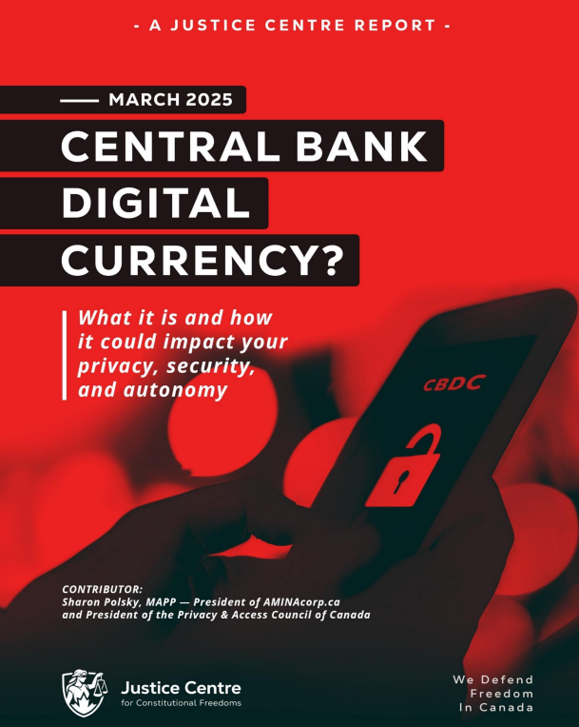
REMINDER
New Credit Card Fees & Lack of Privacy
It is starting – Use cash as much as possible – use credit cards or digital only if there is no other alternative.

The Bank of Canada is admittedly planning for digital currency. It claims that it will not replace cash – BUT – and here is the caveat, it will continue to use cash “notes for as long as Canadians want them.”

In other words, if you don’t use cash, you will lose it. Reading between the lines, it is clear that the Gov’t will simply issue press releases and polls showing most Canadians don’t use and/or don’t want cash, and then the Bank of Canada will claim it has to eliminate cash because few people are using it or want it, and it is, ironically, too costly to maintain printing the notes and coins.

https://www.bankofcanada.ca/digitaldollar/#what-digital-canadian

Bill Still, the US Patriot and author of the incredible documentary, The Money Masters, outlines the results of recent polls showing that 86% of Canadians fear the digital dollar!!! Wow.
87% of Canadians have heard or are aware of the Bank of Canada’s CBDC (Central Bank Digital Currency), and 82% are strongly opposed to it!!
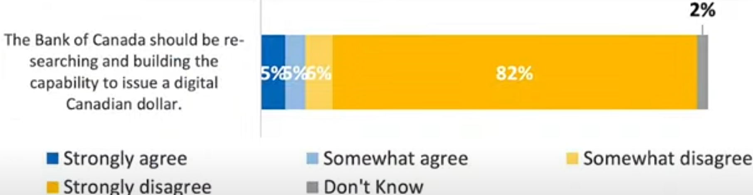

https://www.thestillreport.com/post/bank-of-canada-survey-86-fear-digital-dollar-the-still-report-episode-4280

Companies will not use digital currency if we are not using digital currency!

It will cost them too much in lost business.

Here are two awesome posters that you can distribute to all businesses to put on their entrance doors, advocating for the use of cash. Print on 8 1/2 x 11 glossy hard stock for best results.

For Business owners:
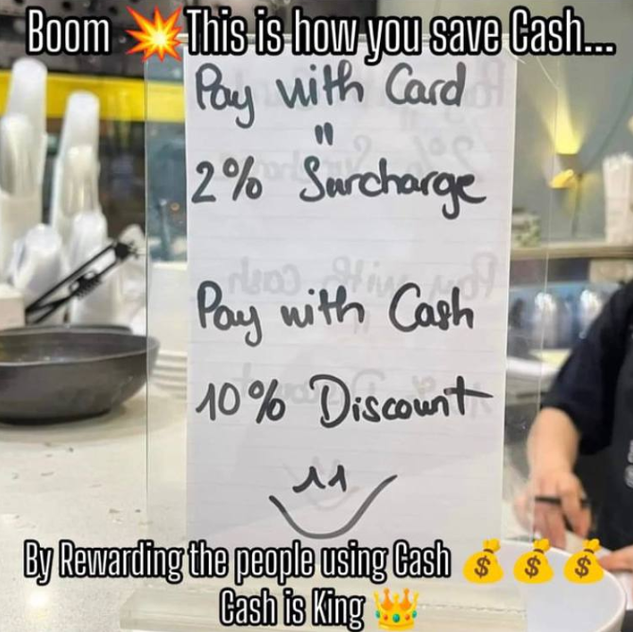
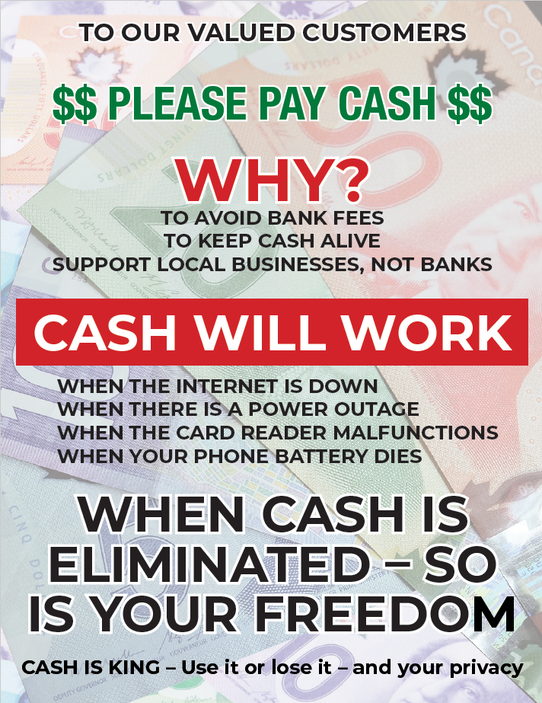
The dangers of digital gov’t ID and currencies are here… you need to use cash as much as possible. As recognized by Freedom Rising, there are many inherent dangers of using digital currency. What do you do, not if, but when:
The internet is down
There is a power outage
The card reader malfunctions
Your phone battery dies or doesn’t work for other reasons

WE SUGGEST YOU CONSIDER THE FOLLOWING AS WELL:

Your phone is stolen
Your passwords are co-opted
Your credit/debit card strip is damaged – needs replacing
There are errors in relation to the quantum of $$ on your card
Gov’t limits your purchases/CRA liens the balance on your card

AND MANY OTHER DANGERS

CLEAR has promoted the non-use of digital currencies and credit/debit cards as much as possible, for years.

Suggested Solution:
Withdraw money on Saturday/Sunday from the bank or bank machine, and then leave your money at home if you are scared to carry it with you, and just carry the amounts of cash for each day’s purchases for the week.

NO MORE CARDS!!!! NO EXCUSES!
USE CASH $$$$$$$$$

Do you want to be the next person to be “unbanked” because of your political beliefs????

Another sample: (thanks Adele)
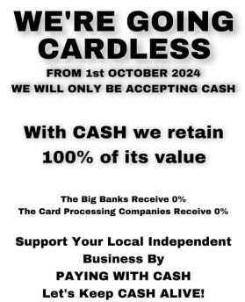


Get these cards below at the CLEAR booth to give out every time you use cash – or print your own to hand out!

Make Business sized cards to hand out at all your cash purchases!
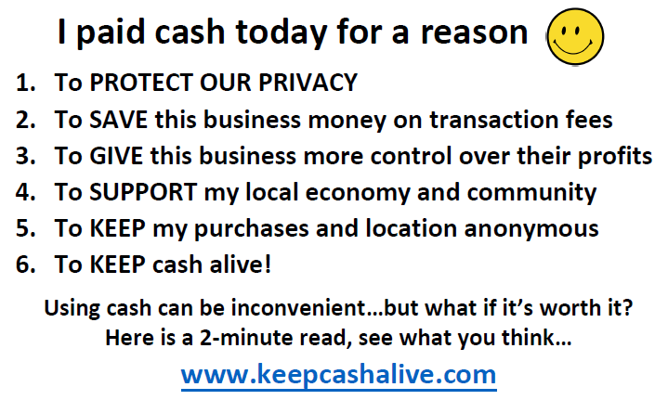

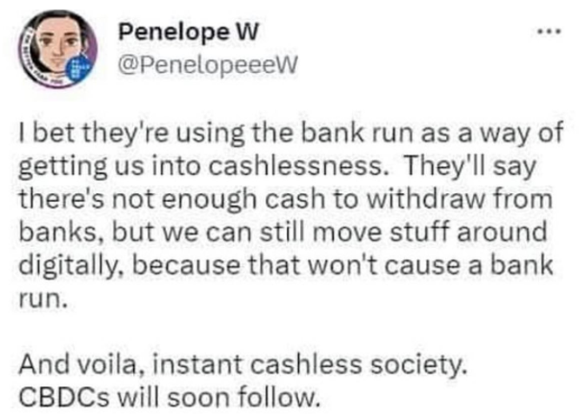

--------------------------------------


Sunday Paper Deliveries
Next delivery day:
Sunday, December 7, 2025
(Weather Permitting)
A small group of dedicated volunteers have been spreading the truth via Druthers deliveries every Sunday for over 2 years now. This is one of the most powerful things a freedom activist can do to help inform the public.

Please email us if you wish to help spread the word of Freedom!

Thank You!
--------------------------------------
Freedom Rallies

Visibility = Credibility

“It ain’t over till it’s over”

Next Kelowna Rallies:

Saturdays 12:00 noon

December 6, 2025
Stuart Park – Christmas Freedom Rally!

December 13, 2025
Hwy 97 & Cooper

Your presence at public rallies/protests opposing gov’t activities – IS the message!!

Help us give away hundreds of Druthers every week to supporting drivers and public!

December 6, 2025 12:00 noon
Vernon Freedom Rally
12:00 p.m. – 2:00 p.m. @ Polson Park
Join Ted for the Largest rally in the North Okanagan, and growing weekly!

North Okanagan Shuswap Freedom Radio
http://s1.voscast.com:11464/stream
---------------
December 6, 2025 12:00 noon
Kamloops Freedom Gathering
Valleyview Centennial Park
---------------
December 6, 2025 12:00 noon
Oliver Freedom Rally
12:00 p.m.
Town Hall

