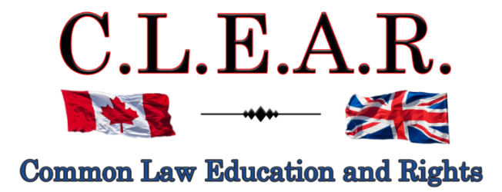

“Promoting Freedom in B.C.”
Freedom activists are critical thinkers!
Our society is so dumbed down and indoctrinated that anyone who is a critical thinker is labeled as a Conspiracy Theorist to avoid critical debates

Did you know: The term ‘conspiracy theorist’ was first coined and used by the CIA to ridicule anyone who opposed the gov’t narrative?
--------------------------------------
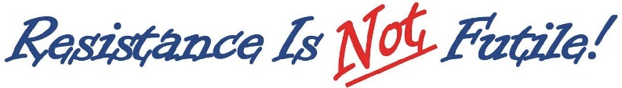
--------------------------------------
It is important to come out on Saturdays to oppose all Gov’t corruption and support others.

Visibility = Credibility Your presence is the message!

Next Freedom Rally is:

January 3, 2026 – New Year’s Freedom Rally
Stuart Park

January 10, 2026
Hwy 97 & Cooper

Help us give away hundreds of Druthers every week to supporting drivers and public!

CLEARLY Important:

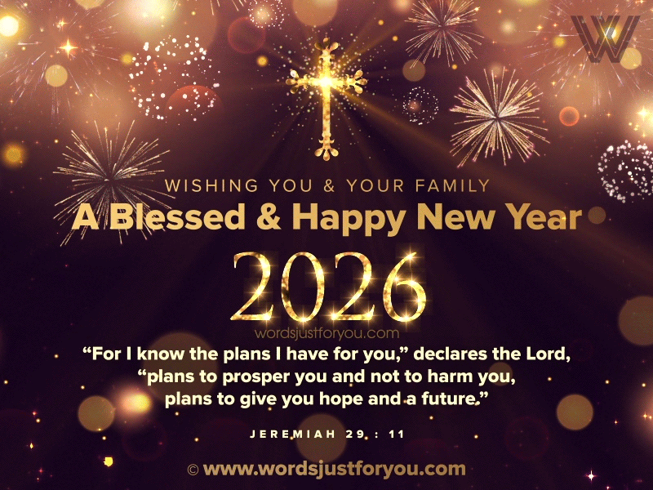
--------------------------------------

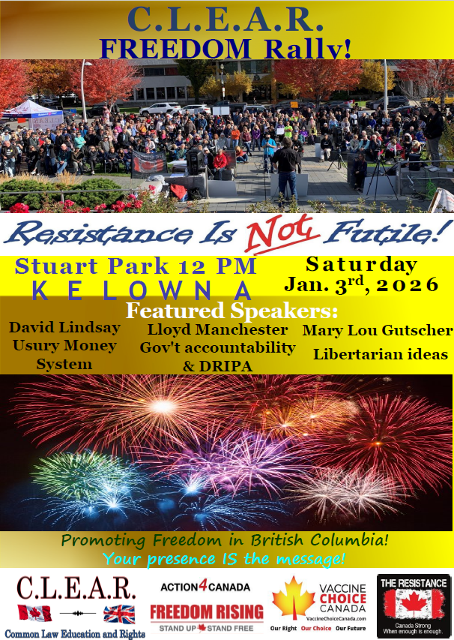
CLEAR Telegram
With hundreds of members now and growing, join us in our C.L.E.A.R. Telegram group! Please remember: no foul language, abuse or vulgarity for any posts, keep posts relevant to today’s freedom issues, humour is fine, be respectful at all times. Government officials, police, agents or their posts are not accepted nor permitted on this site. Please ensure as best you can, that material you post is accurate and correct. Posting false or incorrect information is not acceptable.
Help us ensure all posts are verified for correctness.
Opinions and discussions on relevant issues are also encouraged.
This is a private group for trusted people and friends only. If you wish to join, please email us at: clear2012@pm.me
--------------------------------------

A CLEAR Path Forward: Embracing Freedom in the New Year
Happy New Year to everyone who values freedom, justice, and truth. As we step into 2026, let’s pause and reflect: Where will our common law freedoms lead us in the face of mounting challenges? The answer lies in the unyielding spirit of our Constitutionally enshrined Christian heritage—a heritage that equips us not just to endure, but to triumph over the forces seeking to erode our liberties. This is not merely a tale of resistance, but a story of renewal, rooted in Christ and His teachings, calling us to action in this pivotal year.
Christ said you shall know them by their fruits. Who else is equipping us with the tools to confront the shadows ahead—especially in relation to the Oath issues and the battles for our rights? If they are not, then through ignorance, bliss, or intention, they are complicit in the erosion of our law's foundation, built over millennia, and we must not follow them down that path of surrender. Our Constitutionally enshrined freedoms, including the sacred right/duty to resist unjust laws, are not fleeting whims of man—they are divine gifts, etched into our Constitution under the supremacy of God, fortified by the Christian bedrock of our common law. Let’s explore the trials awaiting us in 2026, and more importantly, the victories we can claim through faith, unity, and unswerving resolve.
The new year dawns with formidable challenges for those who cherish freedom. Governments, under the guise of convenience and security, are pushing digital IDs that threaten to digitize our very identities, linking every aspect of our lives to centralized control. Imagine a world where your ability to travel, bank, or even speak freely hinges on a singular government-issued digital passport— a tool that tracks, monitors, and restricts based on compliance. Closely tied to this is the specter of digital currency, where cash, that last bastion of anonymous exchange, which gov’ts are attempting to phase out in favor of programmable money. What fruits will this bear? Transactions could be approved or denied at the whim of authorities, enforcing behaviors through financial levers— a direct assault on the economic freedoms our forebears fought to secure.
Even more Orwellian are the implications of compelling Canadians to provide ID for online programs and services. In the name of "safety," access to information, social platforms, or essential services might soon require digital verification, creating a surveillance state where anonymity is extinct. Big Brother would not just watch—he would gatekeep, silencing dissent by denying entry to the digital public square. These measures, if unchecked, erode the privacy and autonomy that are hallmarks of a free society, turning citizens into subjects of an all-seeing system.
Compounding these threats are assaults on our property rights, a cornerstone of liberty enshrined in our laws. Recent Indian cases, such as the Cowichan decision, signal a dangerous precedent where historically unsupported claims could upend established ownership, potentially leading to widespread unconstitutional expropriations. Governments, emboldened by judicial nods, might seize lands under pretexts of reconciliation or environmentalism, ignoring the Biblical mandates against theft and the common law's protection of property. What would happen if we abandoned these safeguards? Tyranny would flourish, with property—our homes, farms, and inheritances—vulnerable to arbitrary state whims. These are not abstract fears; they are the fruits of policies that prioritize control over justice.
Yet, in this new year, let us not dwell in despair but ignite hope through the positive forces at our command. Our greatest weapon remains the Coronation Oath of the King, a timeless vow binding the Crown to uphold God's laws, the true profession of the gospel, and the Protestant reformed religion. This Oath, sworn by every monarch since 973 A.D., including King Charles III, is the longest-standing pillar of our Constitution, ensuring that no law contrary to divine principles can stand. Our objective is to launch challenges invoking this Oath against unconstitutional legislation, and we expect resounding success in 2026.
Consider how the Oath safeguards our property rights: It mandates the monarch—and by extension, all government officials sworn to the Crown—to maintain the laws of God, which prohibit theft and unjust seizure. In the face of threats like the Cowichan case, we can invoke this divine imperative, arguing that any erosion of ownership violates the Oath's pledge to protect "spiritual and civil rights and properties." Our efforts to educate and litigate on this front are bearing fruit, with growing awareness that the supremacy of God in our Constitution eclipses man-made abuses. We anticipate judicial affirmations that reinforce these protections, turning back the tide of property grabs and restoring confidence in our heritage.
The supremacy of God, etched into the preamble of our Charter of Rights and Freedoms—"Whereas Canada is founded upon principles that recognize the supremacy of God and the rule of law"—remains our unassailable shield. This is no mere phrase; it subordinates all laws to divine order, empowering us to resist encroachments on freedom. In the coming year, as we press forward with challenges rooted in this truth, expect victories that reaffirm our rights—from online freedoms to economic sovereignty. The wheels of justice grind slowly, but they grind toward truth, and our persistence will prevail.
Let’s not forget, that the power of Queen Elizabeth II to sign the Charter and Constitution Act 1982, originated in and from the Coronation Oath! Clearly, with the Constitutional duty to maintain Christianity in her Oath, she could not give Royal Assent to the Charter if it was to recognize any other god other than the Christian God.
Nor is this a minor issue – the Coronation Oath is the Constitutional foundation for your power of peaceful civil disobedience!
One shining example of expected success is our battle with the City of Kelowna over their attempt to license our outdoor political freedom rallies—our monthly protests against government abuses and illegal activities. The City sought an injunction to ban us, claiming authority to regulate public expression, but we countered with an anti-SLAPP (Strategic Lawsuit Against Public Participation) application under BC's Protection of Public Participation Act. Myself and Lloyd have argued that their move was a blatant attempt to silence dissent, intended only to shut down freedom of expression against government abuses and unconstitutional legislation, including their actions during the COVID era. This was no legitimate regulation—it was a SLAPP suit designed to intimidate and exhaust us.
The City employed a procedure that usually ends in six months or so – it has now been three years and this case remains ongoing and we are still having our public protests!!!
Though in our legal system nothing is guaranteed, we expect a favorable decision on our anti-SLAPP application in the next month or two, dismissing their injunction and awarding costs against the City. We have invested hundreds of hours into this case to protect out vital freedoms and make no mistake - we are correct. However, we also know the judiciary has been politically compromised. Whether this will affect out case remains unknown. We can only hope and pray that the judge upholds the honour of her position and her own oaths.
This expected victory will not only secure our right to rally but set a precedent for freedom fighters across BC, proving that public protests cannot be muzzled under the guise of bureaucracy. It underscores the importance of our gatherings: visibility equals credibility. Evil governments hate the spotlight, and our outdoor rallies keep the flame of truth burning bright in the public eye. We cannot let "out of sight, out of mind" become the norm—our presence reminds Canadians of the stakes and inspires others to join.
In this spirit, solidarity is our unbreakable bond. The new year calls us to support those on the front lines—in courts, education, podcasts, reporting, and protests. Think of the sacrifices: lost jobs, careers, even families, all to expose government corruption and lies, not just in medicine but across every realm. These people deserve our gratitude and support; their fruits sustain our movement. Let us commit to standing together, sharing resources, and amplifying voices. Freedom is a multi-generational struggle—our past generation faltered, making our task harder, but we will not fail our children. Our goal is to leave a better Canada, where liberty thrives unhindered.
We are infiltrating politics, too, with voices like Dallas Brodie boldly placing truths about land claims and residential schools into the legislative record, preventing history's rewrite on lies. Their courage rattles the establishment—Premier David Eby lashes out, calling her names, because the narrative of deception is crumbling. More MLAs and even Kelowna councilors are speaking out, and our projects, involving dedicated souls across Canada, promise fruition in 2026.
As we embrace the new year, let the Coronation Oath guide us: a vow to maintain God's laws, ensuring no unjust measure prevails. If you have duties to God, you have rights against the State! With this Oath, which is the basis of all our law, our challenges to digital tyranny and property threats will succeed. Solidarity, public presence, and faith will carry us forward. Happy New Year—may God's blessings fuel our resolve, and may we fulfill our duties to protect the freedoms that come from Him alone.

Ongoing 2026 Issues/threats to be aware of:

Misrepresentation of our Constitution and Constitutional documents
Privacy violations/deprivations at all levels of society and on the internet
Digital ID
Digital currency
Usury based monetary system/unconstitutional taxation
Deprivation of Property rights in our Constitution/Indian issues
Vaccine dangers
Do viruses even exist?
Municipal 15 min cities/zoning – removal of single-family homes
Immigration, especially third world
Threats to our culture and religion
Crime – especially from immigrants
Gov’t corruption at all levels – voting irregularities and tampering
Biased and/or compromised judiciary
Biased, compromised, subsidized and Communist main stream media (MSM)

Issue overload!

--------------------------------------
Call to Action
Using the Coronation Oath to stop Bill C-9

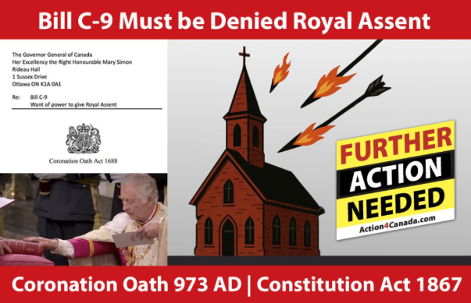

Recently there has been a surge of ongoing attacks on Christianity in Canada by the Liberal Government – and Parliament, as displayed in Bill C-9, which purports to criminalize quoting scripture and classifying it as hate speech under the Criminal Code.

Through all the incredible work from Action4Canada and my own group CLEAR, or Common Law Education and Rights, we have educated Canadians for years on the true source of power in our law and Constitution – that being God himself. I am so thankful for all of Tanya’s ongoing efforts to not only promote, but to insist on a return to Christianity in our Constitution and her supporting Call to Action.

It is an honour to continue to partner with Tanya and Action4Canada on such critically important issues.
All power flows from the Oath. All Members of Parliament have sworn to uphold the Protestant Christian religion in their oaths to the King, and yet are now openly violating these sworn Oaths – the Oath of Allegiance and Oath of Office. Most importantly, the King, via the Governor General in Canada, is now also attempting to openly break his own Coronation Oath by giving this Bill, Royal Assent.

We are now responding on two fronts – making the Governor General Mary Simon aware that she has no power on behalf of the King to give Royal Assent to Bill C-9, and to the MPs themselves, that they have no power to aid and advise the Governor General to give this Bill Royal Assent. Both have sworn Oaths to the King that they would not assist the King to break his own Coronation Oath to us.

Canadians need to make all of these Government officials aware that we know their Oaths prohibit them from allowing Bill C-9 to be passed by Parliament and that we are opposed to the Governor General giving Royal Assent to Bill C-9. We are not allowing them to pass Bill C-9 and remain fiercely opposed to this Bill.

I have put the Governor General on Legal Notice on Dec. 15 of this year, that she has no power to give Royal Assent to Bill C-9 and demanded she uphold her Oaths to the King and refuse to do so. It will be interesting to see her response. But one man may not be not enough.

Call to Action – Your participation!

We have six (6) weeks to mount an aggressive Call to Action campaign, until Parliament resumes sitting on January 26, 2026.

I strongly encourage each and every one of you to support our CLEAR and Action4Canada joint Call to Action by printing and signing your own letter, mailing and emailing them to the Governor General, and make the same demands upon her as I made in my above Legal Notice.

I also urge you to further send a copy of your signed Governor General letter to your Member of Parliament, including our cover letter demanding that your own MP also refuse to vote in support of Bill C-9 next year, pursuant to their Oaths.

And we ask that you get your friends and family members to take a few minutes to do likewise.

This is easy to do.

Simply print, sign the letter to the Governor General, available at both CLEAR and Action4Canada websites, and mail to:

Her Excellency the Right Honourable Mary Simon
Rideau Hall
1 Sussex Drive Ottawa, ON K1A 0A1

You can and should also email her at: info@gg.ca

We also strongly urge everyone to send a copy of your letter to the Governor General to your specific Member of Parliament, along with a printed, signed copy of your letter to your MP, personally or free by Canada Post, also located at CLEAR and Action4Canada.

In short, serve the Governor General with your printed and signed letter. Then serve your own MP with a copy of your letter to him/her and a copy included/attached letter you sent to the Governor General, to allow your MP to see the legal details also binding upon him/her.

All MPs have the duty to aid and advise the King (s. 91 Constitution Act 1867, formerly the British North America Act 1867), and they cannot fulfill this duty to advise the King to break his Oath (the law). MPs need to know that their duties to the King from their Oaths, override all duties to their political Party.

The time for accountability to the Governor General’s Oaths to the King, and from MPs, is now. We need you to support Action4Canada and CLEAR as we become the first organizations in Canada to demand the Governor General uphold Christianity in our law – as the King swore to us under oath that he would do.

As Sir William Blackstone agreed, this Coronation Oath is a contract. We are enforcing our rights under it!

If you have any questions, please email us at: clear2012@pm.me
--------------------------------------
Courts - UPDATE

Falsified assault charge - Appeal
Kelowna Courthouse
R v David Lindsay s. 266 Criminal Code

Thank you for all your support and belief for freedom!!

Remember the Freedom Principle:

An attack against one is an attack against all.
An attack against all, is an attack against one.
--------------------------------------
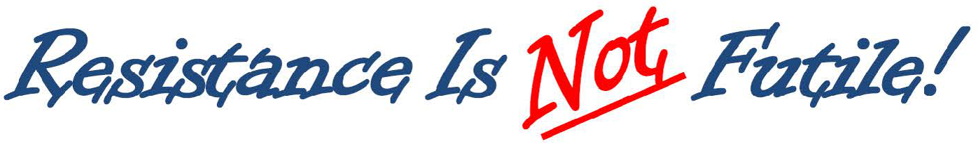
--------------------------------------
FALSIFIED ASSAULT CONVICTION APPEAL
Twyla has been given permission to transcribe my trial hearings for appeal purposes. We are attempting now to get the tapes, and to ensure she has the proper formatting to use to do so.

Thanks to God for this important success!

Update - 20251230
The Crown objected to my Constitutional Challenge to the RCMP Act (policing being exclusively Provincial jurisdiction) and s. 265 (assault – being vague and uncertain and criminalizing all unintentional touching) of the Criminal Code, claiming I needed leave (permission) to raise these issues, arguing they should have been raised at trial.

I have to file my application by January 19, 2026. I take the position leave is not required, especially where no new evidence is required. I will post my application on our website when it is completed and filed.

This won’t be heard until March or April, and my appeal itself is now once again, delayed until the fall.

Keep in mind the falsified charges in this case were laid in Dec. 2021!!!!
---------------------
City of Kelowna v David Lindsay et al
Petition to Stop Rallies at Stuart Park

IMPORTANT LEGAL UPDATE
FREEDOM OF EXPRESSION CASE
Dear Freedom Supporters:

We want to provide you with a critical update regarding our legal battle for freedom of expression.

Continuation of the hearing for our anti-SLAPP application has concluded in late August.
Justice Hardwick has reserved judgment in this case. There is no set date for the release of her judgment.

Kelowna filed a Petition to obtain an injunction to ban our rallies throughout the entire downtown Kelowna area, the most effective areas in the City.

In turn, we filed what is known as an anti-SLAPP application pursuant to the Protection of Public Participation Act. The acronym (SLAPP - Strategic Lawsuit against Public Participation), says it all – the Petition is a SLAPP action intended to prohibit our public participation at Stuart Park exposing gov’t corruption and lies. We applied to have it struck.
https://www.bclaws.gov.bc.ca/civix/document/id/complete/statreg/19003
We urge everyone to pray for success in this case. This type of case has never been heard in Canada and we need God on our side to ensure a precedent in our favour. Please pray that J. Hardwick will come down on the side of freedom.
Our Court documents in this case are located on our website at:

https://clearbc.org/david/
City of Kelowna documents and pleadings are now placed on our website for public viewing:

https://clearbc.org/city-of-kelowna/

NOTE: The City of Kelowna has once again started issuing me falsified tickets for holding our Constitutionally protected Freedom Rallies. Their position is that we need a licence to do so. To date, these charges have not yet been heard.
-------------------
Our anti-SLAPP Application: A Strong Legal Defense
Our anti-SLAPP Application is incredibly detailed and well-prepared. As the legal maxims state: “Fraud lurks in generalities”, and, “the details make all the difference.”
The City’s strategy is clear:
- Ignore Constitutional law and attempt to redefine protesting as a licenced activity.
- Gloss over key legal principles and interpretations, and hope the courts accept their broad, unfounded claims.
- Bylaw us out of existence—forcing us away from public spaces and out of the public eye.
But we refuse to be silenced.
We knew we had to be meticulously prepared, with extensive evidence and legal arguments to counter every false claim. And we are prepared.

The Broader War on Free Speech
This case is not an isolated attack—it is part of a coordinated effort to suppress free expression across Canada, particularly in British Columbia and Alberta.
- Online censorship is expanding.
- Private interest groups, funded by the government, are targeting businesses that support free speech, threatening them with boycotts and false accusations. Many businesses break contracts with us at the last minute out of fear.
- Municipal governments are being weaponized to push freedom advocates out of public spaces.
- And most recently under the Communist Liberal Government, ongoing refusals to permit certain media outlets into their press releases and government functions, to ensure only Liberal Government supported media is allowed in.

Their tactic is simple: Out of sight, out of mind. If they can erase us and our messages from public view, they believe they can stifle dissent.
Thank you for your unwavering support.
--------------------------------------

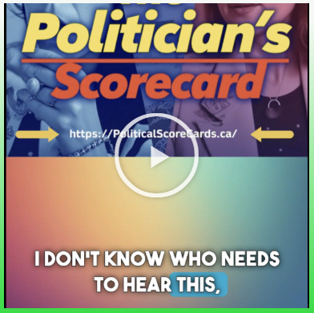
https://politicalscorecards.ca/

https://politicalscorecards.ca/election-integrity-survey-results/

--------------------------------------

--------------------------------------
chrome-extension://efaidnbmnnnibpcajpcglclefindmkaj/https://www.jccf.ca/wp-content/uploads/2023/04/Digital-ID-Surveillance-and-the-Value-of-Privacy_Justice-Centre-for-Constitutional-Freedoms.pdf
--------------------------------------
Wins of the Week #105
And Dr. Trozzi and Ted Kuntz
Wins of the Week

https://www.drtrozzi.news/p/wins-of-the-week-ep105-top-wins-of?r=1ri3is

--------------------------------------

--------------------------------------



Guidelines for Peaceful Protesting/Gathering/Rallies and/or Attending Events (eg. Council Meetings, School Boards, Handing out Flyers)
https://action4canada.com/know-your-rights-guidelines

Check out A4C for some of the most successful actions and strategies available to us!

And a big thank you to Tanya for all her hard work and dedication and support for the Christian principles that founded our nation!

https://action4canada.com/

--------------------------------------
CASH UPDATES
In a mixed set of updates here.
CBDC Updates:
https://libertysentinel.org/exposing-trumps-true-character/

Canadian reporter Alex Newman explains what gov’ts around the world are doing with CBDCs right now.

India: advertising about banning Bitcoin
Kuwait: Forced over 1 million citizens to hand over their bio-metric data (including fingerprints) and suspending services if they do not do so, including withdrawing or transferring money.
Date for this was Sept. 30.
35 000 bank customers suspended from using bank services

England: Bank England is preparing to force digital currencies if the banks do not do so.

93% of Central Banks in the world are working on a CBDC – this is truly frightening.

USA: House of Representatives voted to pass a bill, The Anti-Surveillance State Act, 216-192, prohibiting the Federal Reserve from issuing a CBDC. It is concerning however, many still voted against this.
Florida: Passed a law banning CBDCs!
--------------
Support Protection of Cash Now – in Parliament!
Bill C-400
SUMMARY
This enactment provides for the development and implementation of a framework to ensure that cash continues to be available throughout Canada.
It also amends the Currency Act and the Bank of Canada Act to remove the Governor in Council’s power to call in coins and notes. Finally, it amends the Bank of Canada Act to prohibit the Bank of Canada from issuing a digital form of the dollar.
https://www.parl.ca/documentviewer/en/44-1/bill/C-400/first-reading
https://preventgenocide2030.org/keep-cash-alive-support-bill-c-400/
--------------
The Bank of Canada (B of C) has recently announced plans to suspend introduction of a Central Bank Digital Currency (CBDC) to the public.

https://www.kitco.com/news/article/2024-09-20/bank-canada-suspends-plans-introduce-cbdc-public
While this may sound victorious on its face, and there is much positive to say when such plans are shelved or put on hold, please remember the use of the word “suspend” as opposed to “cancel”.
Has the B of C simply decided to wait on the outcomes and research from other countries and then simply tag along?
In this past summer, the B of C was recommending Canada provide its own CBDC for digital payments. This apparently has been suspended or now put on hold. We can only hope for some permanency to this decision.
We need a Constitutional amendment that 100% absolutely provides for the mandatory use and acceptance of cash for all transactions – in any amount. So, if you wish to pay $1 000 000.00 for a house in $100/bills, you should be allowed to so do. That is privacy.
Conversely, Google has announced that the Google Wallet can now function as digital ID, based on the selling point of course, of convenience to the exclusion of all privacy. Once privacy is lost, so is freedom.
“Imagine starting a vacation like this,” Google Wallet executive Alan Stapelberg wrote in a blog post last week. “You arrive at the airport and breeze through security by tapping your phone to a reader, scanning your boarding pass and ID. While waiting to board, you grab a drink at an airport bar, tapping your phone to prove your age. When you arrive at your destination, you find your rental car and leave the lot without stopping for an in-person ID check because you already provided the necessary information in the rental car app. You check into your hotel online and your key is issued straight to your digital wallet. You do all of this with your phone — no physical wallet required.”
https://www.thegoldreport.com/news/google-announces-digital-id-wallet
Though a bit late, in June, 2024, Norway passed legislation requiring use of cash!
https://x.com/petersweden7/status/1843050565443395924?s=52
Yes to cash
https://x.com/jackunheard/status/1843056003497218451?s=52
--------------
REMINDER
New Credit Card Fees & Lack of Privacy
It is starting – Use cash as much as possible – use credit cards or digital only if there is no other alternative.
The Bank of Canada is admittedly planning for digital currency. It claims that it will not replace cash – BUT – and here is the caveat, it will continue to use cash “notes for as long as Canadians want them.”

In other words, if you don’t use cash, you will lose it. Reading between the lines, it is clear that the Gov’t will simply issue press releases and polls showing most Canadians don’t use and/or don’t want cash, and then the Bank of Canada will claim it has to eliminate cash because few people are using it or want it, and it is, ironically, too costly to maintain printing the notes and coins.

https://www.bankofcanada.ca/digitaldollar/#what-digital-canadian

Bill Still, the US Patriot and author of the incredible documentary, The Money Masters, outlines the results of recent polls showing that 86% of Canadians fear the digital dollar!!! Wow.
87% of Canadians have heard or are aware of the Bank of Canada’s CBDC (Central Bank Digital Currency), and 82% are strongly opposed to it!!
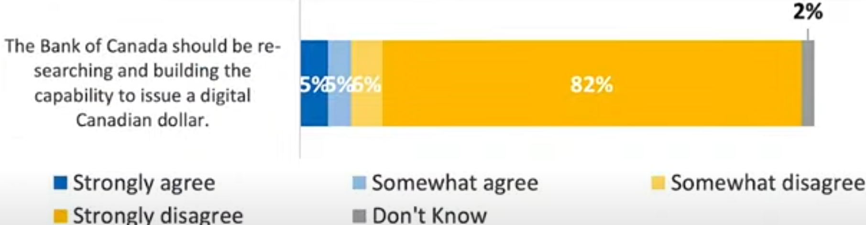

https://www.thestillreport.com/post/bank-of-canada-survey-86-fear-digital-dollar-the-still-report-episode-4280

Companies will not use digital currency if we are not using digital currency!

It will cost them too much in lost business.

Here are two awesome posters that you can distribute to all businesses to put on their entrance doors, advocating for the use of cash. Print on 8 1/2 x 11 glossy hard stock for best results.

For Business owners:
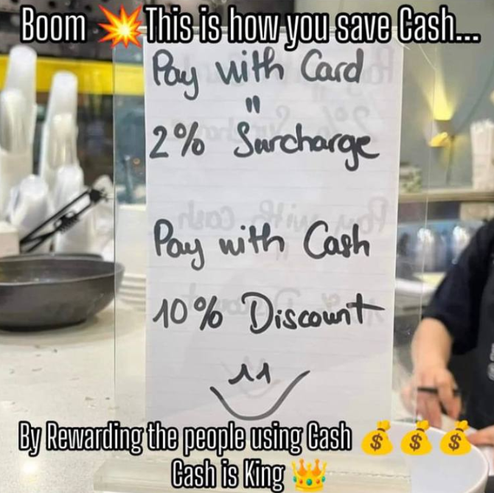
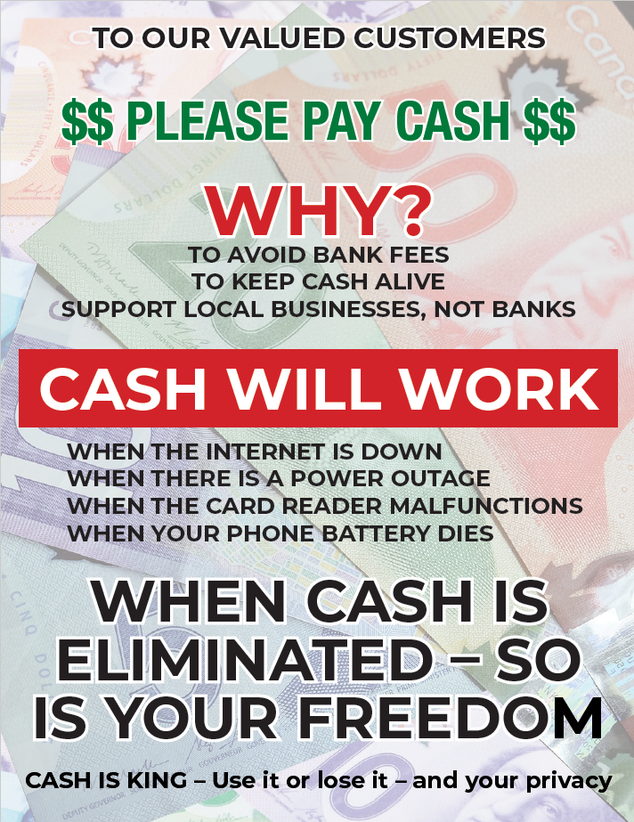
The dangers of digital gov’t ID and currencies are here… you need to use cash as much as possible. As recognized by Freedom Rising, there are many inherent dangers of using digital currency. What do you do, not if, but when:
The internet is down
There is a power outage
The card reader malfunctions
Your phone battery dies or doesn’t work for other reasons

WE SUGGEST YOU CONSIDER THE FOLLOWING AS WELL:

Your phone is stolen
Your passwords are co-opted
Your credit/debit card strip is damaged – needs replacing
There are errors in relation to the quantum of $$ on your card
Gov’t limits your purchases/CRA liens the balance on your card

AND MANY OTHER DANGERS

CLEAR has promoted the non-use of digital currencies and credit/debit cards as much as possible, for years.

Suggested Solution:
Withdraw money on Saturday/Sunday from the bank or bank machine, and then leave your money at home if you are scared to carry it with you, and just carry the amounts of cash for each day’s purchases for the week.

NO MORE CARDS!!!! NO EXCUSES!
USE CASH $$$$$$$$$

Do you want to be the next person to be “unbanked” because of your political beliefs????

Another sample: (thanks Adele)

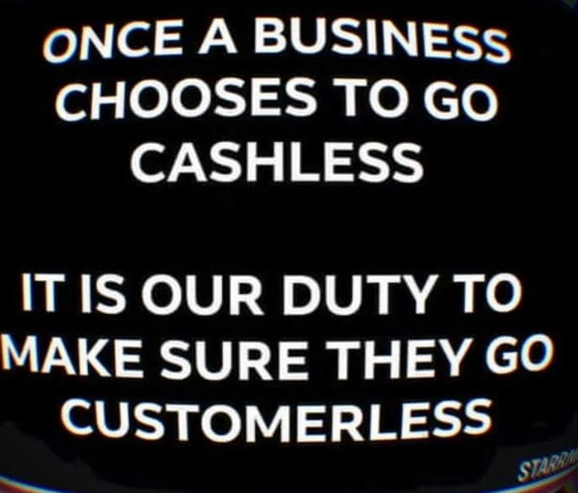

Get these cards below at the CLEAR booth to give out every time you use cash – or print your own to hand out!

Make Business sized cards to hand out at all your cash purchases!

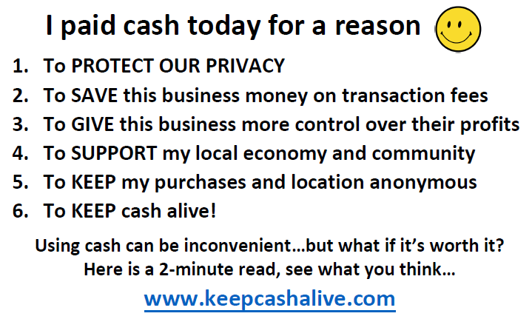

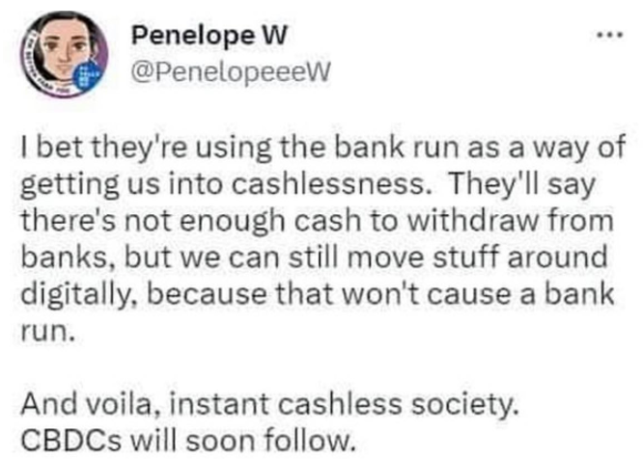

--------------------------------------


Sunday Paper Deliveries
Next delivery day:
Sunday, January 4, 2026
(Weather Permitting)
Capril Mall, Gordon & Harvey St. (Hwy 97)
A small group of dedicated volunteers have been spreading the truth via Druthers deliveries every Sunday for over 2 years now. This is one of the most powerful things a freedom activist can do to help inform the public. We meet every Sunday in the Capri Mall parking lot between A&W and DeDutch Pannekoeke House.
Please note that if you have chosen to "fall back" to end Daylight Savings Time, meet-up time will be at 9:30 am for you until the government tells you to spring forward again in March. For those who don't adhere to this senseless ritual, Druthers deliveries will continue to be at 10:30 am, Daylight Savings Time, all year long.
Thank You!
--------------------------------------

Freedom Rallies

Publicity is the soul of justice

“It ain’t over till it’s over”

Next Kelowna Rallies:

Saturdays
12:00 noon – 1:30 p.m

Next Freedom Rally is:

January 3, 2026 – New Year’s Freedom Rally
Stuart Park

January 10, 2026
Hwy 97 & Cooper

Join us for important announcements on the local, legal scene, and informative speakers!
January 3, 2026 12:00 noon
Vernon Freedom Rally
12:00 p.m. – 2:00 p.m. @ Polson Park
Join Ted for the Largest rally in the North Okanagan, and growing weekly!
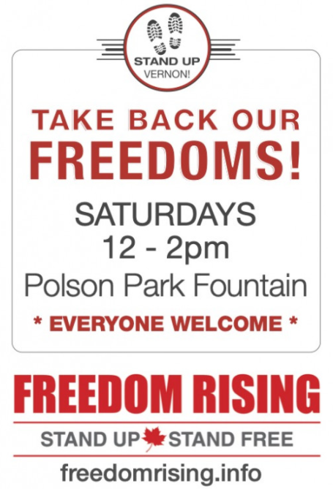
North Okanagan Shuswap Freedom Radio
http://s1.voscast.com:11464/stream
---------------
January 3, 2026 12:00 noon
Kamloops Freedom Gathering
Valleyview Centennial Park
---------------
January 3, 2026 12:00 noon
O.K. Falls Freedom Rally
11:30 a.m.
Across from Esso Station
---------------
January 3, 2026 2:00 noon
Oliver Freedom Rally
12:00 p.m.
Town Hall

