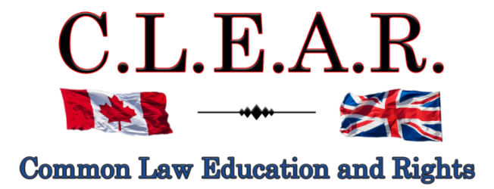

“Promoting Freedom in B.C.”
Freedom activists are critical thinkers!
Our society is so dumbed down and indoctrinated that anyone who is a critical thinker is labeled as a Conspiracy Theorist to avoid critical debates

Did you know: The term ‘conspiracy theorist’ was first coined and used by the CIA to ridicule anyone who opposed the gov’t narrative?
--------------------------------------
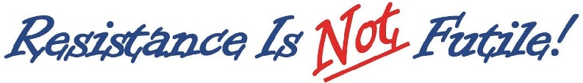
--------------------------------------
It is important to come out on Saturdays to oppose all Gov’t corruption and support others.

Visibility = Credibility Your presence is the message!

Next Freedom Rally is:

January 3, 2026 Cancelled due to weather

January 10, 2026 – New Year’s Freedom Rally
Stuart Park

January 17, 2026
Hwy 97 & Cooper

Help us give away hundreds of Druthers every week to supporting drivers and public!
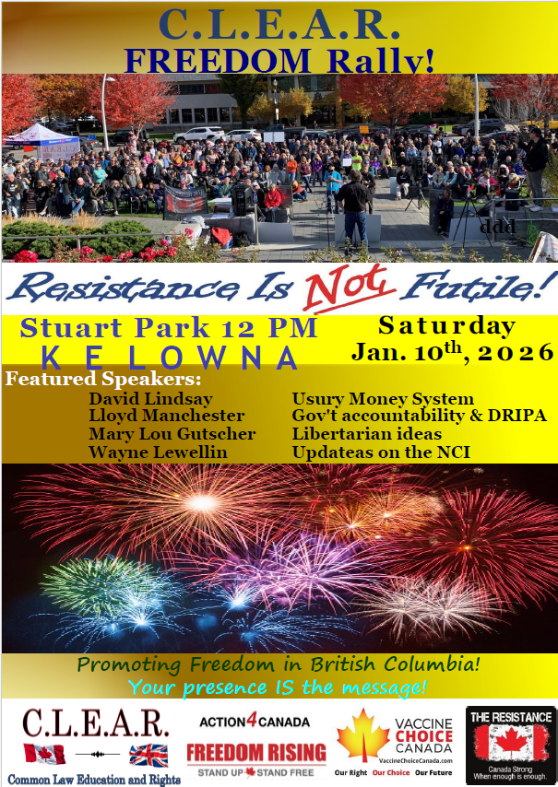
CLEAR Telegram
With hundreds of members now and growing, join us in our C.L.E.A.R. Telegram group! Please remember: no foul language, abuse or vulgarity for any posts, keep posts relevant to today’s freedom issues, humour is fine, be respectful at all times. Government officials, police, agents or their posts are not accepted nor permitted on this site. Please ensure as best you can, that material you post is accurate and correct. Posting false or incorrect information is not acceptable.
Help us ensure all posts are verified for correctness.
Opinions and discussions on relevant issues are also encouraged.
This is a private group for trusted people and friends only. If you wish to join, please email us at: clear2012@pm.me
--------------------------------------

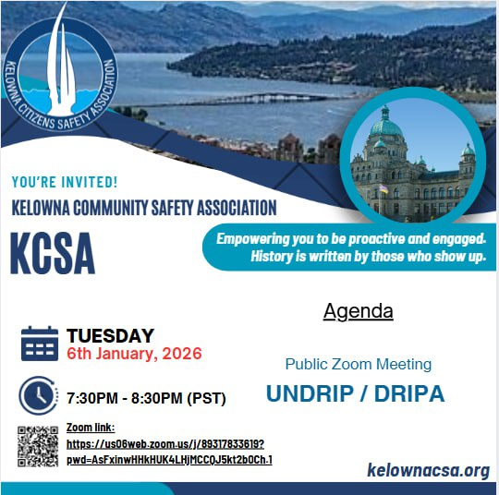

You are invited to join,
KCSA is holding a public information session on DRIPA/ UNDRIP
Zoom Meeting, 6th of Jan, 2026 at 7:30pm

Speakers: Lloyd Manchester & Tamara Terlesky (Realtor)
Zoom link:
https://us06web.zoom.us/j/89317833619?pwd=AsFxinwHHkHUK4LHjMCCQJ5kt2b0Ch.1
--------------------------------------
Call to Action
Using the Coronation Oath to stop Bill C-9

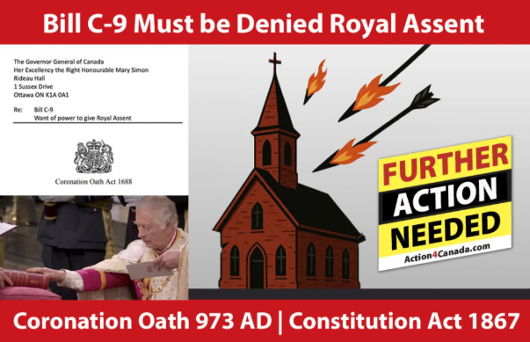

Recently there has been a surge of ongoing attacks on Christianity in Canada by the Liberal Government – and Parliament, as displayed in Bill C-9, which purports to criminalize quoting scripture and classifying it as hate speech under the Criminal Code.

Through all the incredible work from Action4Canada and my own group CLEAR, or Common Law Education and Rights, we have educated Canadians for years on the true source of power in our law and Constitution – that being God himself. I am so thankful for all of Tanya’s ongoing efforts to not only promote, but to insist on a return to Christianity in our Constitution and her supporting Call to Action.

It is an honour to continue to partner with Tanya and Action4Canada on such critically important issues.
All power flows from the Oath. All Members of Parliament have sworn to uphold the Protestant Christian religion in their oaths to the King, and yet are now openly violating these sworn Oaths – the Oath of Allegiance and Oath of Office. Most importantly, the King, via the Governor General in Canada, is now also attempting to openly break his own Coronation Oath by giving this Bill, Royal Assent.

We are now responding on two fronts – making the Governor General Mary Simon aware that she has no power on behalf of the King to give Royal Assent to Bill C-9, and to the MPs themselves, that they have no power to aid and advise the Governor General to give this Bill Royal Assent. Both have sworn Oaths to the King that they would not assist the King to break his own Coronation Oath to us.

Canadians need to make all of these Government officials aware that we know their Oaths prohibit them from allowing Bill C-9 to be passed by Parliament and that we are opposed to the Governor General giving Royal Assent to Bill C-9. We are not allowing them to pass Bill C-9 and remain fiercely opposed to this Bill.

I have put the Governor General on Legal Notice on Dec. 15 of this year, that she has no power to give Royal Assent to Bill C-9 and demanded she uphold her Oaths to the King and refuse to do so. It will be interesting to see her response. But one man may not be not enough.

Call to Action – Your participation!

We have six (6) weeks to mount an aggressive Call to Action campaign, until Parliament resumes sitting on January 26, 2026.

I strongly encourage each and every one of you to support our CLEAR and Action4Canada joint Call to Action by printing and signing your own letter, mailing and emailing them to the Governor General, and make the same demands upon her as I made in my above Legal Notice.

I also urge you to further send a copy of your signed Governor General letter to your Member of Parliament, including our cover letter demanding that your own MP also refuse to vote in support of Bill C-9 next year, pursuant to their Oaths.

And we ask that you get your friends and family members to take a few minutes to do likewise.

This is easy to do.

Simply print, sign the letter to the Governor General, available at both CLEAR and Action4Canada websites, and mail to:

Her Excellency the Right Honourable Mary Simon
Rideau Hall
1 Sussex Drive Ottawa, ON K1A 0A1

You can and should also email her at: info@gg.ca

We also strongly urge everyone to send a copy of your letter to the Governor General to your specific Member of Parliament, along with a printed, signed copy of your letter to your MP, personally or free by Canada Post, also located at CLEAR and Action4Canada.

In short, serve the Governor General with your printed and signed letter. Then serve your own MP with a copy of your letter to him/her and a copy included/attached letter you sent to the Governor General, to allow your MP to see the legal details also binding upon him/her.

All MPs have the duty to aid and advise the King (s. 91 Constitution Act 1867, formerly the British North America Act 1867), and they cannot fulfill this duty to advise the King to break his Oath (the law). MPs need to know that their duties to the King from their Oaths, override all duties to their political Party.

The time for accountability to the Governor General’s Oaths to the King, and from MPs, is now. We need you to support Action4Canada and CLEAR as we become the first organizations in Canada to demand the Governor General uphold Christianity in our law – as the King swore to us under oath that he would do.

As Sir William Blackstone agreed, this Coronation Oath is a contract. We are enforcing our rights under it!

If you have any questions, please email us at: clear2012@pm.me
--------------------------------------

